Gr 10 Science: Biology & Gr 11 & 12 Biology
Islamic Contribution to Math and Science
There is a lack of acknowledgment of contributions made by historic Islamic scholars’ in many fields including science and math, despite four centuries of rich contributions during the 9th to 13th centuries. In fact, during this Islamic golden age, concepts instrumental in the furtherment of science (as we practice it today) stem from concepts of accuracy, precision, experimentation, and peer review. These ideas were refined and passed on from the scientist during this period. In Islamic centers multicultural scholars were brought together solely for the pursuit of knowledge. Ancient texts were translated into Arabic and ideas were further developed through experimentation while great attention was paid to precision and accuracy.

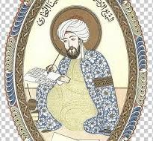
Watch the following video and answer the questions below.
A miniature of Avicenna– Image via Wikimedia Commons
- Modern science is built on a lot of research that was accumulate when?

- What did Islamic scholars contribute during this time period?

- When was medicine first treated as a true science?

- How was medicine treated as a true science during the Golden Age of Science?

- What does neonatal encephalopathy mean?

- What ground-breaking research is Hamad Hospital conducting to treat babies with neonatal encephalopathy?

- What is a control group used for in a study?
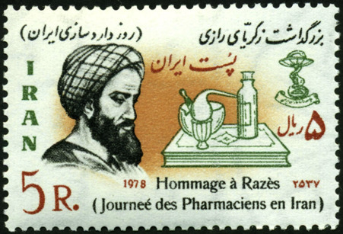
- What is a double-blind placebo control study?

- Who was first to use a control group?
- What was Al-Razi studying when he used a control group?

- Where is Al-Razi from?
(Afshar et al., 2020)
- How did Al-Razi determine where the best place to build a hospital was?

- Who in the 17th century was credited with ground-breaking research on heart circulation?

- Who was Al-Nafis?

- What did Al-Nafis describe in his writings?

- What does Dr Magdi Yacoob specialize in?
- Al-Nafis, a Syrian scholar, was known for many great contributions but his most important contribution was for…

- What did the Greek physician Galen say about blood circulation and the heart?

- How did Al-Nafis explain that Galen was incorrect?

- Al-Nafis described the blood circulating to which organ before returning to the hearts?

- When was Al-Nafis’s work recognized?

- Where did hospitals giving free medicine and treatment first appear?
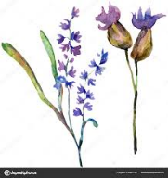
(Lavender: Images via deposit photos)
- Al-Sina’s text Canon of Medicine was used for how long around the world?
- What are some benefits of lavender?

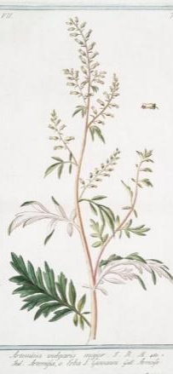
- What are some benefits of wormwood?

- What are some benefits of sage?
(Wormwood: Images via picryl)

- What are some benefits of black cumin?

- How was knowledge spread through out the Islamic Empire?

- What made Chinese paper better than the local paper?

- What is the connection between the Islamic Golden Age and the Renaissance?

- What is a genome?

- What does a genome sequencer do?

- How long did it take to sequence the first human genome?
- How long does it take to sequence a genome today?

“During the Golden Age of Muslim Civilisation medical care was free to all. Hospitals were built in many cities across the Muslim World, and cutting-edge treatments such as cataract operations, regular vaccinations, internal stitching, bone setting, and medical education in teaching hospitals were part of standard practice, as was the awareness of the importance of nutrition and exercise in maintaining life and preserving health.”

(Top five medical books on healthy living from MUSLIM CIVILISATION, 2020)

