Nobel chemistry prize awarded to 2 scientists for developing CRISPR gene editing tool

(questions at the end by Sathurthia Selvanayagam)

CRISPR-Cas9 method allows scientists to precisely edit specific genes to remove errors that lead to disease
CBC - The Associated Press · Posted: Oct 07, 2020 6:20 AM ET
https://www.cbc.ca/news/technology/nobel-prize-chemistry-2020-1.5753279
Two scientists won the Nobel Prize in Chemistry Wednesday for developing a way of editing genes likened to "molecular scissors" that offer the promise of one day curing inherited diseases.
Working on opposite sides of the Atlantic, French microbiologist Emmanuelle Charpentier and American biochemist Jennifer A. Doudna came up with a method known as CRISPR-Cas9 that can be used to change the DNA of animals, plants and microorganisms with extremely high precision.
It was only the fourth time that a Nobel in the sciences was awarded exclusively to women, who have long received less recognition for their work than men in the prize's 119-year history.
Charpentier and Doudna's work allows for laser-sharp snips in the long strings of DNA that make up the "code of life," allowing scientists to precisely edit specific genes to remove errors that lead to disease.
"There is enormous power in this genetic tool, which affects us all," said Claes Gustafsson, chair of the Nobel Committee for Chemistry. "It has not only revolutionized basic science, but also resulted in innovative crops and will lead to groundbreaking new medical treatments."
Dr. Francis Collins, who led the drive to map the human genome, said CRISPR "has changed everything" about how to approach solutions to diseases with a genetic cause, such as sickle cell disease.
"You can draw a direct line from the success of the human genome project to the power of CRISPR-cas to make changes in the instruction book," said Collins, director of the National Institutes of Health, which helped fund Doudna's work.
But many also cautioned that the technology raises serious ethical questions and must be used carefully. Much of the world became more aware of CRISPR in 2018, when Chinese scientist He Jiankui revealed he had helped make the world's first gene-edited babies, to try to engineer resistance to future infection with the AIDS virus.
His work was denounced worldwide as unsafe human experimentation because of the risk of causing unintended changes that can pass to future generations, and he is currently in prison.
In September, an international panel of experts issued a report saying it's still too soon to try to make genetically edited babies because the science isn't advanced enough to ensure safety, but they mapped a pathway for any countries that want to consider it.

First time all-female team wins science Nobel
Charpentier, 51, spoke of the shock of winning.
"Strangely enough I was told a number of times [that I'd win], but when it happens you're very surprised and you feel that it's not real," she told reporters by phone from Berlin after hearing of the award, announced in Stockholm by the Royal Swedish Academy of Sciences. "But obviously it's real, so I have to get used to it now."
When asked about the significance of two women winning, Charpentier said that while she considers herself first and foremost a scientist, "it's reflective of the fact that science becomes more modern and involves more female leaders."
"I do hope that it will remain and even develop more in this direction," she said.
There have been three times a woman has won a Nobel in the sciences by herself. In 1911, Marie Curie was the sole recipient of the chemistry award, as was Dorothy Crowfoot Hodgkin in 1963. In 1983, Barbara McClintock won the Nobel for medicine. This is the first time an all-female team has won a science prize.
Doudna told The Associated Press of her own surprise — including that she learned she'd won from a reporter.
"I literally just found out, I'm in shock," she said. "I was sound asleep."
"My greatest hope is that it's used for good, to uncover new mysteries in biology and to benefit humankind," said Doudna, who is affiliated with the University of California, Berkeley, and is paid by the Howard Hughes Medical Institute, which also supports AP's Health and Science Department.

Research published in 2012
The breakthrough research done by Charpentier and Doudna was only published in 2012, making the discovery very recent compared to many Nobel wins that are often only honoured after decades have passed.
Speaking to reporters from the Max Planck Unit for the Science of Pathogens in Berlin, which she leads, Charpentier said despite how recently it was developed, the method is now widely used by scientists researching diseases, developing drugs and engineering new plants.
Among the most promising therapies already being developed are those for eye diseases and blood disorders, such as sickle cell disease and beta thalassemia, she said. It could also have applications in the growing field of cancer immunotherapy.
Developing hardy crops is another promising direction, said Charpentier.
"I think this is very important considering the challenge we are facing of climate change."
The Broad Institute at Harvard and MIT have been in a long court fight over patents on CRISPR technology, and many other scientists did important work on it, but Doudna and Charpentier have been most consistently honoured with prizes for turning it into an easily usable tool.

Third Nobel prize awarded this week
The prestigious award comes with a gold medal and prize money of 10 million krona ($1.5 million Cdn), courtesy of a bequest left more than a century ago by the prize's creator, Swedish inventor Alfred Nobel. The amount was increased recently to adjust for inflation.
On Monday, the Nobel committee awarded the prize for physiology and medicine to Americans Harvey J. Alter and Charles M. Rice and British-born scientist Michael Houghton, who currently works at the University of Alberta, for discovering the liver-ravaging hepatitis C virus.
Tuesday's prize for physics went to Roger Penrose of Britain, Reinhard Genzel of Germany and Andrea Ghez of the United States for their breakthroughs in understanding the mysteries of cosmic black holes.
The other prizes are for outstanding work in the fields of literature, peace and economics.

Nobel chemistry prize awarded to 2 scientists for developing CRISPR gene editing tool

CRISPR-Cas9 method allows scientists to precisely edit specific genes to remove errors that lead to disease
CBC - The Associated Press · Posted: Oct 07, 2020 6:20 AM ET
Click the link for the full article:https://www.cbc.ca/news/technology/nobel-prize-chemistry-2020-1.5753279
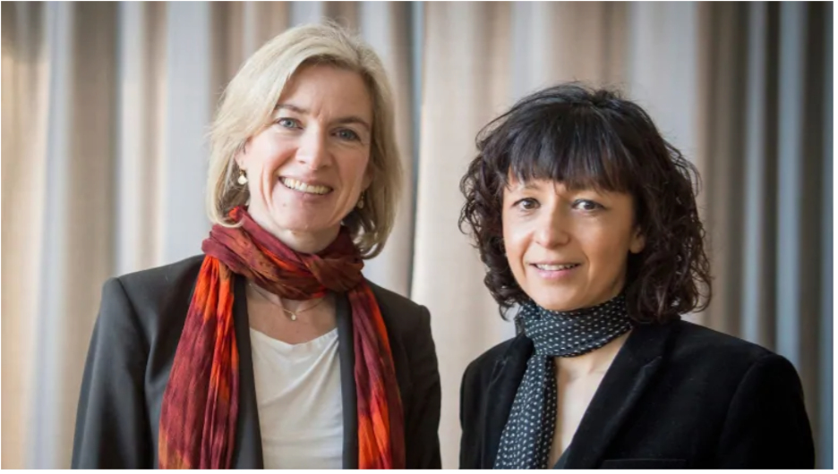
Picture taken from article

Overview
Working on opposite sides of the Atlantic, French microbiologist Emmanuelle Charpentier and American biochemist Jennifer A. Doudna came up with a method known as CRISPR-Cas9 that can be used to change the DNA of animals, plants and microorganisms with extremely high precision. Among the most promising therapies already being developed are those for eye diseases and blood disorders, such as sickle cell disease and beta thalassemia, she said. It could also have applications in the growing field of cancer immunotherapy.
Discussion Questions
- Who are the two women Nobel Laureates in chemistry for 2020?
_______________________________________

- Pernilla Wittung Stafshede says that DNA is the code of life which is made of nearly 6 billion bases that are minute. To edit this genome, what method was introduced by the two laureates?
__________________________________________
- Claes Gustafsson introduces the concept of CRISPR Cas 9. How does it help with the future of genetic engineering?
___________________________________________
- Where does this system come from?
_________________________________________
- What is CRISPR?
____________________________________________________________________
____________________________________________________________________

- How can CRISPR defend the bacteria from later viral infections?
____________________________________________________________________
____________________________________________________________________
- What is a tracer RNA and what molecular scissor proteins are involved in this process?
____________________________________________________________________
____________________________________________________________________
____________________________________________________________________

- The CRISPR RNA and tracer RNA fuse together to form a single guide RNA. How does this and the bacterial proteins work together to edit the DNA?
____________________________________________________________________
____________________________________________________________________
____________________________________________________________________
- How does CRISPR cas 9 help with Sickle Cell Anaemia?
____________________________________________________________________
____________________________________________________________________
____________________________________________________________________
Extension Question
Although science isn’t advanced enough to consider genetic engineering, they definitely have devised a path for countries that want to consider it. Much of the world became more aware of CRISPR in 2018, when Chinese scientist He Jiankui revealed he had helped make the world's first gene-edited babies, to try to engineer resistance to future infection with the AIDS virus. His work was denounced worldwide as unsafe human experimentation because of the risk of causing unintended changes that can pass to future generations, and he is currently in prison.
- Think about some ethical issues related to genetic engineering, cloning and genetic modification.
____________________________________________________________________
____________________________________________________________________
____________________________________________________________________

