Introduction
The accompanying curriculum and teaching ideas are for use in a grade 11 university physics class. These activities can be used during the electricity and magnetism strand. These activities address curriculum expectations related to circuit analysis, in particular, how voltage, current, and resistance differ between series and parallel circuits (Ontario Ministry of Education, 2008a). The expectations related to circuit analysis are first covered in the physics strand of the grade nine academic course, (Ontario Ministry of Education, 2008b) as such these activities should be a bit of a review for most students and can be run through quickly. The activities were designed to accompany and build on examples presented in the Nelson Physics 11 textbook (DiGuieseppe et al., 2011).
The activities were designed to create a thinking classroom and highlight differentiated instruction and gamification in the university physics classroom. A lot of research has been done to develop a thinking classroom and problem-solving skills in mathematics. Research has shown two main techniques that could be easily implemented into a classroom. First was the use and implementation of groupings, which can not only help students to develop collaboration skills, but using a grouping strategy such as visible random groupings maintained student enthusiasm and time on task (Liljedahl, 2015). Further research has also indicated that having student work on non-permanent surfaces (such as whiteboards) has shown a notable increase to the time spent on-task and decreases time to notation (Liljedahl, 2015). Most evidence has indicated that vertical non-permanent surfaces seem to keep students on task and eager when compared to other work techniques (Forrester, Sandison, & Denny, 2017; Liljedahl, 2015). As physics has a similar structure to mathematics, I decided to incorporate these findings and techniques into minds-on activities for the start of lessons attached. Students will be placed into random groupings at the beginning of every lesson and work on an old contest problem from the Ontario Association of Physics Teachers contest (Ontario Association of Physics Teachers, n.d.).
Further studies indicate the importance of differentiated instruction in the science classroom. The process of differentiated instruction is a cycle between knowing your learner and adjusting your teaching and assessment style to fit the needs of your students (EduGAINS, 2016). To address differentiated instruction, I have provided a few ways to teach circuit physics so that the diverse needs of students can be met. In addition to teaching content with different styles, some of the most common, low-preparation strategies to differentiate that focus on providing students with opportunities for collaboration and choice (Bohannan, 2016; Maeng & Bell, 2015). By combining the strategies used for minds-on activities and incorporating group work problems throughout the lessons and diverse teaching strategies, these activities address differentiated instruction in the physics classroom.
Lastly, I intend for these activities to address gamification in the physics classroom. Gamification involves the implementation of game design elements into teaching through the use of points, badges, leaderboards, rules, and levels (Tolentino & Roleda, 2019). Studies have shown the gamification techniques can increase student motivation and achievement (Tolentino & Roleda, 2017, 2019). With the literature support in mind, I designed a wrap-up activity for students to complete upon reviewing resistance in circuits that works to address gamification in the classroom.

Safety Considerations
For the Kirchhoff’s Law voltage demonstration, ensure that your circuits are fully set up before turning on and plugging in your power supply or connecting your circuits to the batteries. Connecting to your power source last will minimize the risk of electrical shock when setting up the circuit. Try to set up your circuits so that all students can see them from their seats without needing to move. If students need to move closer to view the circuit, ensure any cables (i.e. those connected to a power supply) are secure and out of the way to avoid any tripping hazards.
The remainder of the activities presented do not have any special equipment needs. However, these activities will have students moving around the classroom. Before the class starts, ensure the floor is clear of any tripping hazards for the paths you plan on sending students. Tripping hazards may include but are not limited to garbage cans, recycling bins, power cables, extra chairs or tables. When students get up to move locations for activities, ensure they place any books or bags on or in their desk, and they tuck in their chairs to remove any additional tripping hazards.

Activities

Kirchhoff’s Laws Activities

Activity Set-Up
- Before class, use a random group generator (such as the one available from the Random Lists Website) to assign students to a group of three for the opening problem.
  - Post student grouping on the board so students can group up as they arrive to class.
- The recommended opening problem can be found in Appendix I.
  - Have this problem visible by posting on the main class board (chalkboard, whiteboard, or SMARTboard) for students to begin solving in their groups.
- Set up vertical or horizontal non-permanent surfaces for students to work on while solving the opening problem.
  - Examples of these surfaces include chalkboards, whiteboards, or laminated chart paper or personal whiteboard.
  - If none of these surfaces are available, regular chart paper will work.
  - Student engagement is best when the chart paper is secured to walls or other vertical orientation.
    - Taping the paper to the walls or using easels is recommended.
- If you are planning on using the handout available in Appendix II, have it posted on your class website or photocopied so that students can follow along.
- For the demonstration of the voltage law, acquire six incandescent bulbs, two power sources, and enough wires to set up two circuits.
  - One circuit will have three bulbs set up in series.
  - The other circuit will have three bulbs set up in parallel.
  - Have the two circuits set up on the teacher’s desk or any other area where all students will be able to see both circuits.
  - The photo below from the University of California, Santa Barbara, shows an example of the desired set up.
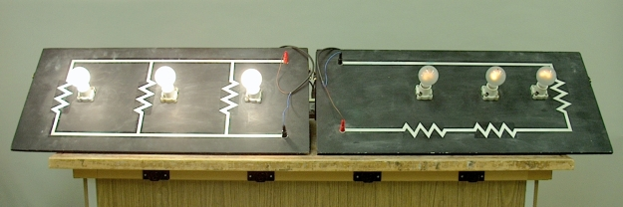
Figure 1 Example circuits of three bulbs in a parallel and series orientation (Grace, n.d.)
  - If you can not acquire the materials to do this demonstration in person, below are two YouTube videos that can have the desired effect.
    - What’s the difference between lightbulbs in series and parallel? (Allain, 2014)
    - Series and Parallel Circuits - Lightbulb Brightness (The Organic Chemistry Tutor, 2019)
- For the demonstration of the current law, ensure your classroom is free of any obstacles before class begins.
  - Encourage students to put any materials they brought to class on or in their desk before starting the activity.

Running the Activity
- Spend the first ten to fifteen minutes of the class with students discussing the problem based on their previous knowledge.
  - Circulate through the classroom and give groups of students hints if they are struggling.
  - Keep track of the procedures students are using to solve the problem and select a few exemplars.
  - When the ten to fifteen minutes has completed, have your exemplars present their strategy to their peers.
- Have students return to their desks. For the rest of the lesson, you can have students follow along on the notes in Appendix I.
- For the presentation of the voltage law, draw students’ attention to the two circuits set up on the teacher’s desk.
  - Explain that both circuits consist of three bulbs, but one circuit has the bulbs set up in series, and the other has the bulbs set up in parallel.
    - If using one of the two videos, follow the same procedure as below but explain to students that in the video, they will see circuits with bulbs set up in series and parallel.
  - Have the students discuss with their desk mate or nearest students what they think will happen when the circuits are turned on.
  - The main guiding question should be: will there be a difference in the bulb brightness depending on the circuit orientation.
  - Have students discuss and record their hypotheses on the board.
  - If students believe that their will be a difference, ask them why and to hypothesize which circuit will be brighter.
  - Turn on both circuits and indicate that the parallel circuit has brighter bulbs.
  - Discuss this revelation in relation to the students’ hypotheses.
  - Show students how this relates to Kirchhoff’s Voltage Law and how it is used in circuit analysis.
- For the presentation of the current law, students will act out the circuit.
  - Have your students get up and gather at a corner of your classroom.
    - As students are moving, remind them to tuck in their chairs and ensure that there are no obstacles on the classroom floor.
  - Select three volunteers from your students.
    - These volunteers will act as the lightbulbs for your circuits.
    - Arrange your bulbs as a series circuit.
  - The rest of the students will serve as electrons.
  - Send your electrons out in groups of three with the instruction to high-five any lightbulbs they cross in their path.
  - Have your bulbs keep track of any high fives they receive.
  - Record the total number of electrons, and high fives each bulb receives in a table on the board.
  - Reorient your bulbs so that they are now in a parallel circuit.
  - Send your electrons off in groups of three again but with the following instructions:
    - the first electron will go down the first path
    - the second electron will go down the middle path
    - the third electron will go down the last path.
  - Record the total number of electrons and the high fives each bulb receives on a table on the board
  - Compare your two rows and have students discuss what this means in a circuit
  - Show students how this activity relates to Kirchhoff’s Current Law.
- For the rest of the class, have groups of students work through some simple circuit analysis problems.

Resistance in Circuits

Activity Set-Up
- Before class, use a random group generator (such as the one available from the Random Lists Website) to assign students to a group of three for the opening problem.
  - Post student grouping on the board so students can group up as they arrive to class.
- The recommended opening problem can be found in Appendix I.
  - Have this problem visible by posting on the main class board (chalkboard, whiteboard, or SMARTboard) for students to begin solving in their groups.
- Set up vertical or horizontal non-permanent surfaces for students to work on while solving the opening problem.
  - Examples of these surfaces include chalkboards, whiteboards, or laminated chart paper or personal whiteboard.
  - If none of these surfaces are available, regular chart paper will work.
  - Student engagement is best when the chart paper is secured to walls or other vertical orientation.
    - Taping the paper to the walls or using easels is recommended.
- If you are planning on using the handout available in Appendix III, have it posted on your class website or photocopied so that students can follow along.
- For the wrap-up activity, use the same random grouping generator to assign students to groups of four.
  - Have these groupings ready on a slide or sheet of paper to post on the board after the lesson.
- Print off enough copies of the circuit gameboards and resistance pieces in Appendix IV so that each group will have their own copy.
  - If possible, have gameboards and pieces printed on cardstock and laminated to ensure longevity.

Running the Activity
- Spend the first ten to fifteen minutes of the class with students discussing the problem based on their previous knowledge.
  - Circulate through the classroom and give groups of students hints if they are struggling.
  - Students should be encouraged to make connections to Kirchhoff’s Laws.
  - Keep track of the procedures students are using to solve the problem and select a few exemplars.
  - When the ten to fifteen minutes has completed, have your exemplars present their strategy to their peers.
- Have students return to their desks.
- For the rest of the lesson, you can have students follow along on the notes in Appendix III.
- Derive the relationship between total resistance and the resistor in series and parallel using Ohm’s and Kirchhoff’s Laws.
  - Try to keep students involved in this process and have them suggest possible next steps before doing them.
- Explain the rules of the wrap-up activity to students.
  - Groups of four students will be given two game boards of a circuit and values for the resistors and total resistance.
  - Students must appropriately place their resistors of the correct circuit before their group can move on to the next circuit.
- Post the randomly generated groups you had made for the wrap-up activity on the board.
- Have a representative from each group come forward and pick up their first two potential circuits and the resistors and total resistance for one of the circuits.
- Students must assign their resistors to the correct circuit before moving on to the next circuit.
- Have students bring their completed circuit to the teacher’s desk or put their hand up to have their circuit verify.
- Once their circuit is checked, students will get an additional circuit and resistors.
- Circuits should get more difficult as students progress through the activity (as if they were levelling up in a video game).

Appendix I - Opening Problems

Kirchhoff’s Laws
A circuit is connected as shown. All light bulbs are identical. When the switch S in the circuit is closed, which bulb(s) other than 4 become(s) brighter?
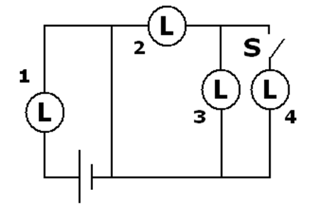
Answer: No other bulbs become brighter.

Resistance in Circuits
In the circuit shown, all five resistors are identical. Which resistor(s) will have the greatest potential difference across it(them)?
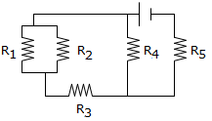
Answer: R₅, the circuit branches and splits the current before all other resistors. The branches join together before R₅ leading to R₅ having all the current flow through it and experience the greatest potential difference due to V=IR.

Appendix II - Kirchhoff’s Laws Lesson Handout
U4 – L04
Kirchhoff’s Laws
Learning Goals
- I will be able to state both cases of Kirchhoff's voltage and current laws
- I will be able to apply Kirchhoff's laws when analyzing mixed circuits
Kirchhoff’s Voltage Law (KVL)
The voltage law can be stated as follows:
In any complete path in an electric circuit, the total electric potential increase at the source(s) is equal to the total electric potential decrease throughout the rest of the circuit.

- For a series circuit all the loads must share the potential difference since there is only one path
- The relationship is then:
$$V_{series}=V_{1}+V_{2}+V_{3}+…$$
- For a parallel circuit has more than one path, therefore the potential difference must be the same as through the source
- The relationship is then:
$$V_{parallel}=V_{1}=V_{2}=V_{3}=…$$

Kirchhoff’s Current Law (KCL)
The current law can be stated as follows:
In a closed circuit, the amount of current entering a junction is equal to the amount of current exiting a junction.

- In a series circuit, there is only one path, therefore there are no junctions
- The relationship is then:
$$I_{series}=I_{1}=I_{2}=I_{3}=…$$
- In a parallel circuit, there can be many paths, therefore there can be many junctions
- The relationship is then:
$$I_{parallel}=I_{1}+I_{2}+I_{3}+…$$

Analyzing Mixed Circuits
In the following circuit V_{source} = 12 V and V₁ = V₂. What is V₃?
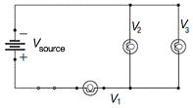
Answer: V₃ = 6 V

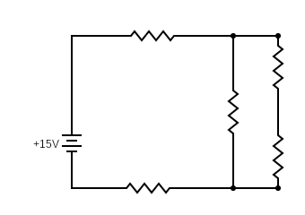
In the following circuit, I₁ = 80 mA and I₃ = 20 mA. Determine I₂, I₄ and I₅.
I₁
I₂
I₃
I₄
I₅

Answer: I₂ = 60 mA, I₄ = 20 mA, I₅ = 80 mA

Create a circuit where V₁ = V₂ and V₁ + V₃ + V₄ = V_{source}.

Answer: orientation may vary, but V₁ and V₂ must be in parallel, V₃ and V₄ in series with parallel components

Homework: pg. 522 #1-2

Appendix III - Resistance in Circuits Note
U4 – L05
Resistance in Circuits
Learning Goals
- I will be able to state both equivalent resistance equations
- I will be able to apply equivalent resistance equations when analyzing mixed circuits
Resistors in Circuits
- Resistors can be wired either in series or in parallel
- Often, we try to determine the total resistance for a circuit
- This is commonly called the equivalent resistance (R_{t}) and it is the total resistance of a group of resistors in series or in parallel
- Consider a series circuit
V_{series} = V₁ + V₂ + V₃ + …
- But from Ohm’s Law: $V=IR$
I_{series}R_{series} = I₁R₁ + I₂R₂ + I₃R₃ + …
- But from Kirchhoff’s Current Law: I_{series} = I₁ = I₂ = I₃ + …
I_{series}R_{series} = I_{series}R₁ + I_{series}R₂ + I_{series}R₃ + …
Therefore
R_{series} = R₁ + R₂ + R₃ + …

- Consider a parallel circuit
I_{parallel} = I₁ + I₂ + I₃ + …
- But from Ohm’s Law: $I=\frac{V}{R}$
$$\frac{V_{parallel}}{R_{parallel}}=\frac{V_{1}}{R_{1}}+\frac{V_{2}}{R_{2}}+\frac{V_{3}}{R_{3}}+…$$
- But from Kirchhoff’s Voltage Law: V_{parallel} = V₁ = V₂ = V₃ + …
$$\frac{V_{parallel}}{R_{parallel}}=\frac{V_{parallel}}{R_{1}}+\frac{V_{parallel}}{R_{2}}+\frac{V_{parallel}}{R_{3}}+…$$
Therefore
$$\frac{1}{R_{parallel}}=\frac{1}{R_{1}}+\frac{1}{R_{2}}+\frac{1}{R_{3}}+…$$

Analyzing Resistance in Circuits
Consider three 15 Ω resistors wired in series and then in parallel, determine the equivalent resistance in each case.

Answer: series – R_{t} = 45 Ω, parallel - R_{t} = 5 Ω

- If resistors are connected in series, then the total/equivalent resistance becomes greater than that of the individual resistors
- If connected in parallel, then the total/equivalent resistance becomes less than that of the individual resistors
- Often circuits contain a mixture of both series and parallel resistor
Determine the equivalent resistance in the following circuit if each resistor has a resistance of 6 Ω.
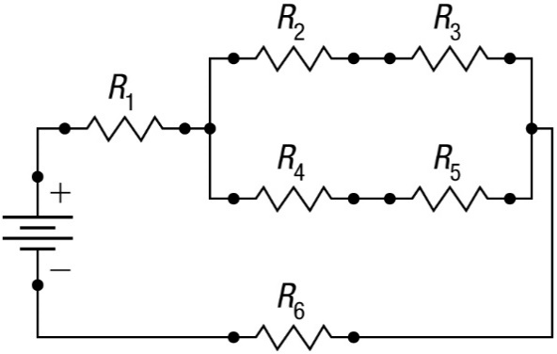
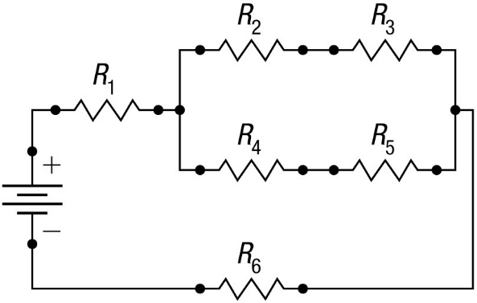

Answer: R_{t} = 18 Ω (to solve, first find R₂₋₃ and R₄₋₅, then find R₂₋₅, then find R_{t})

Homework: pg. 530 #5

Appendix IV - Resistance Circuit Handout Cards and Boards
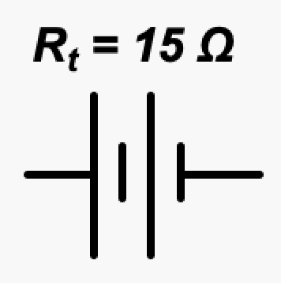 | 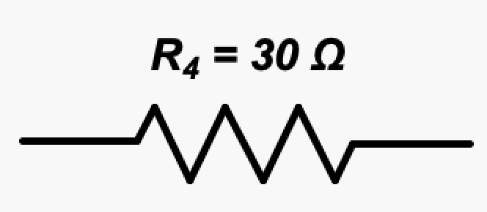
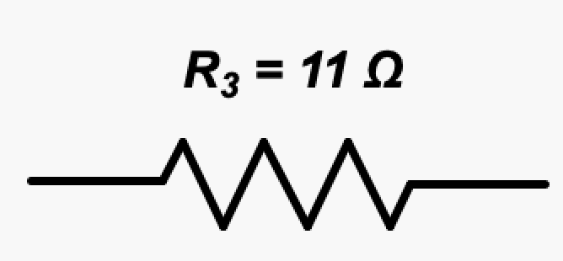 | 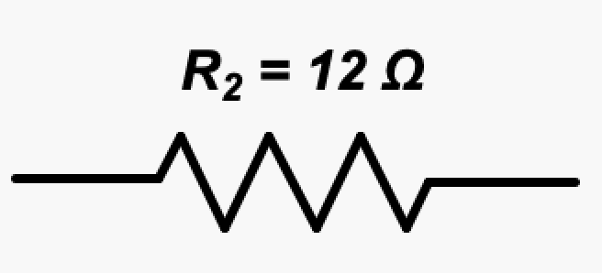
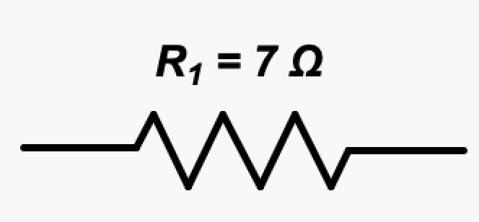 | 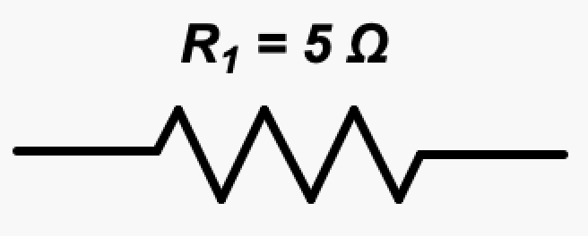
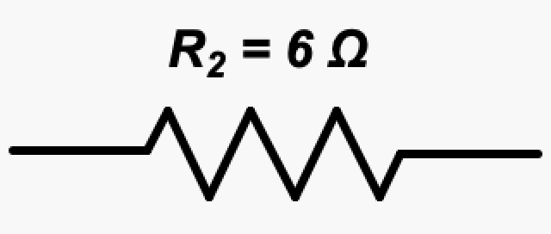 | 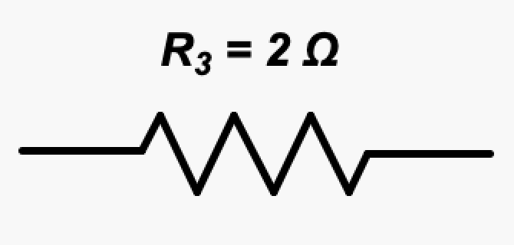
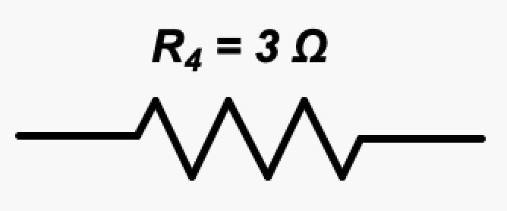 | 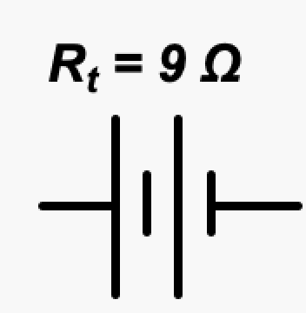
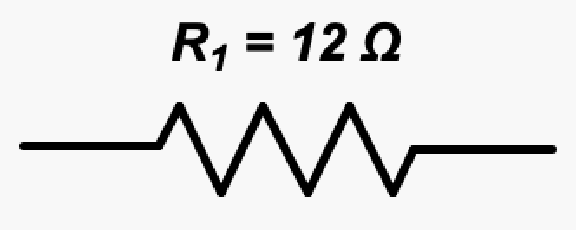 | 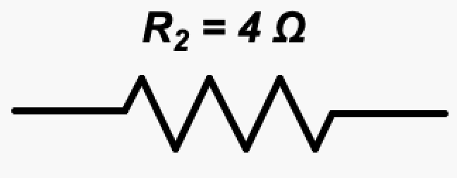
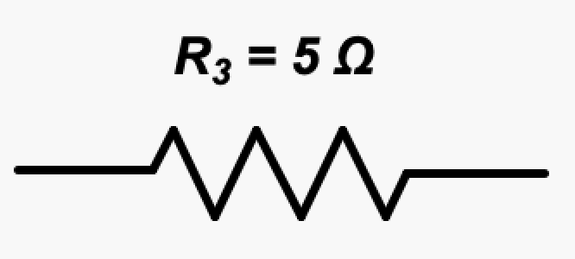 | 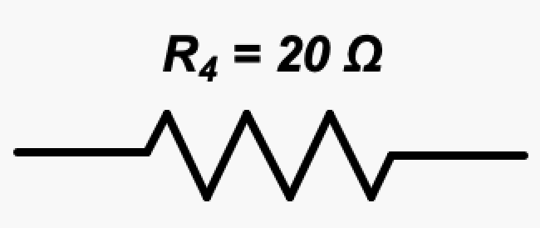
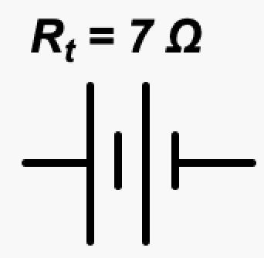 | 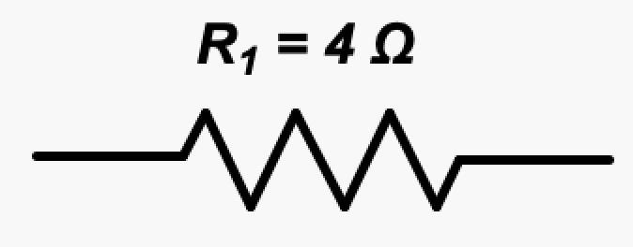
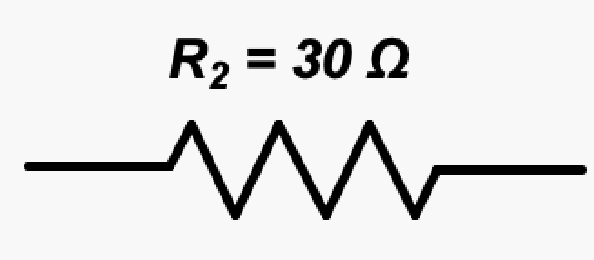 | 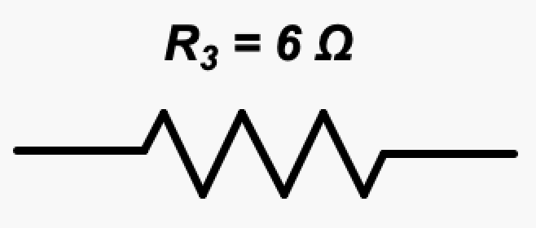
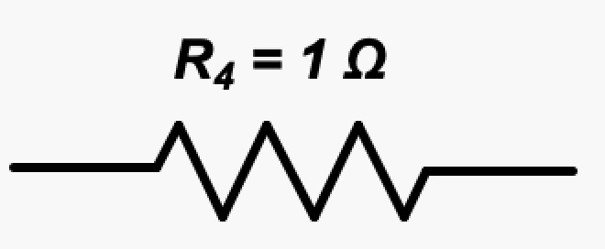 | 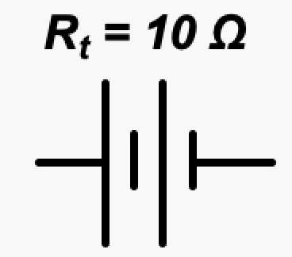
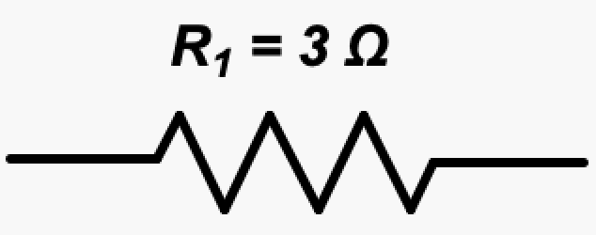 | 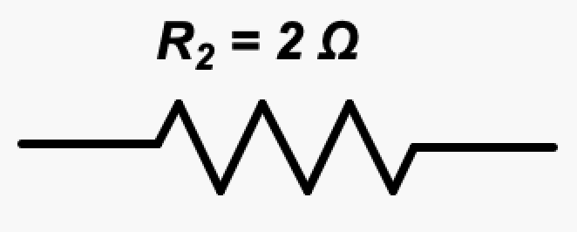
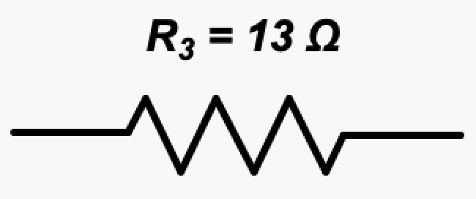 | 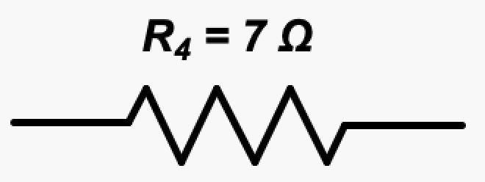
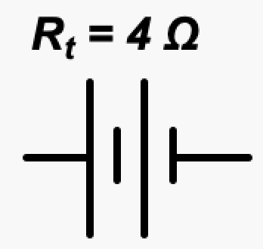 | 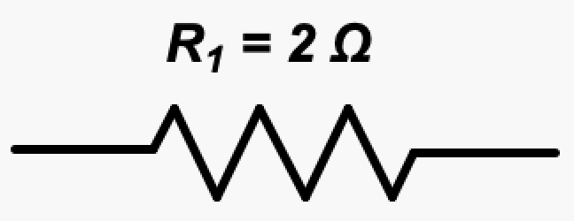
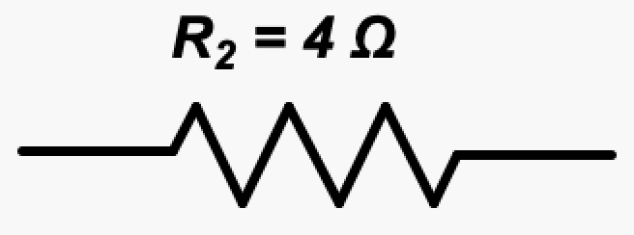 | 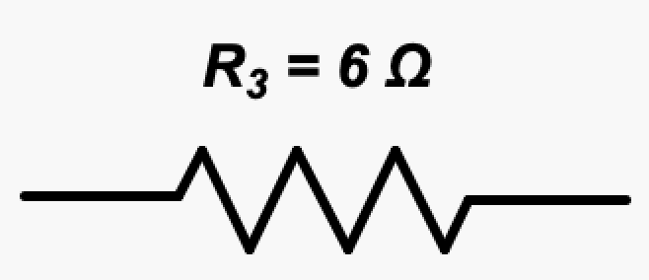
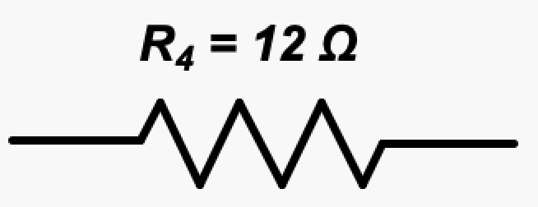 | 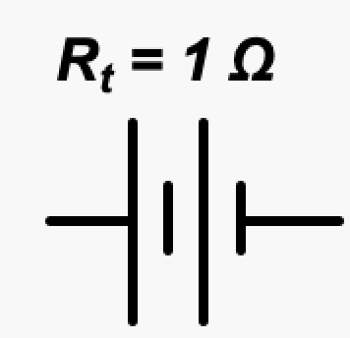

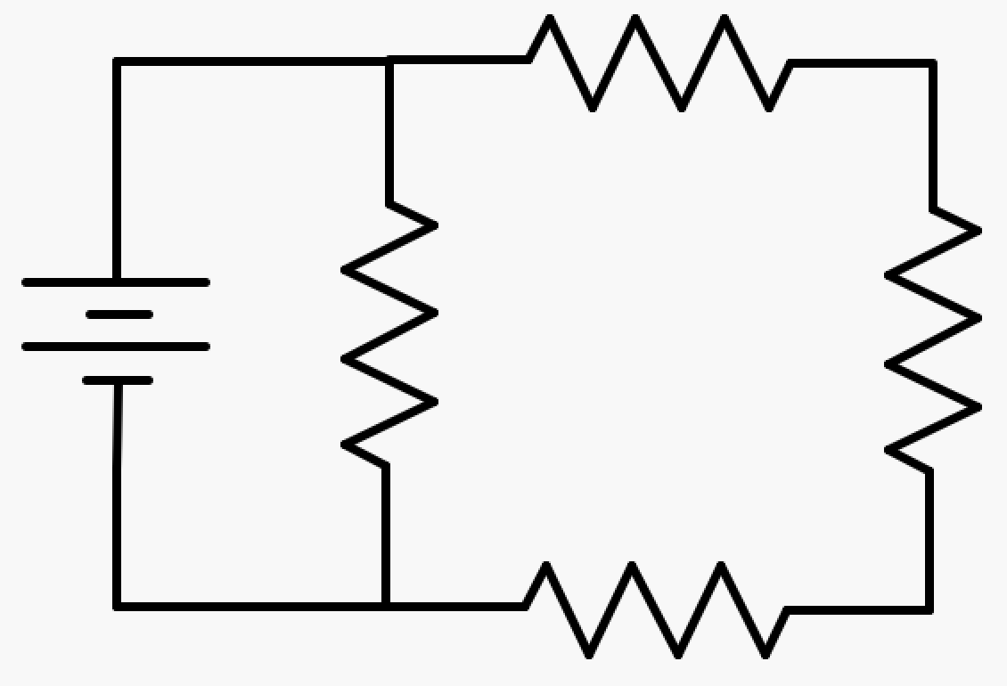

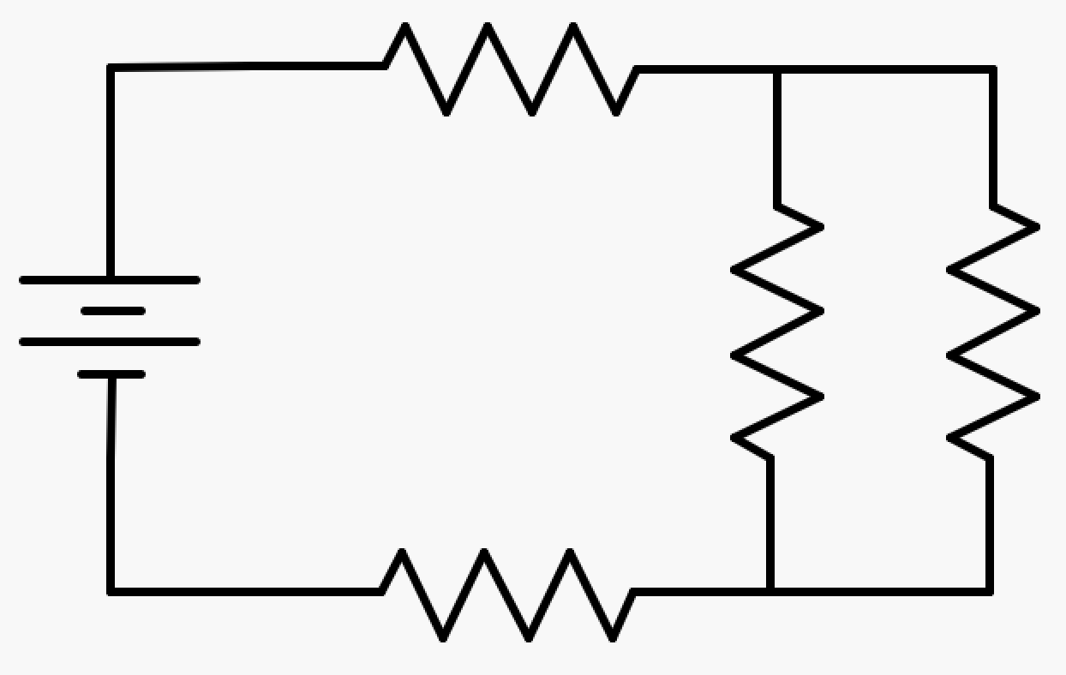

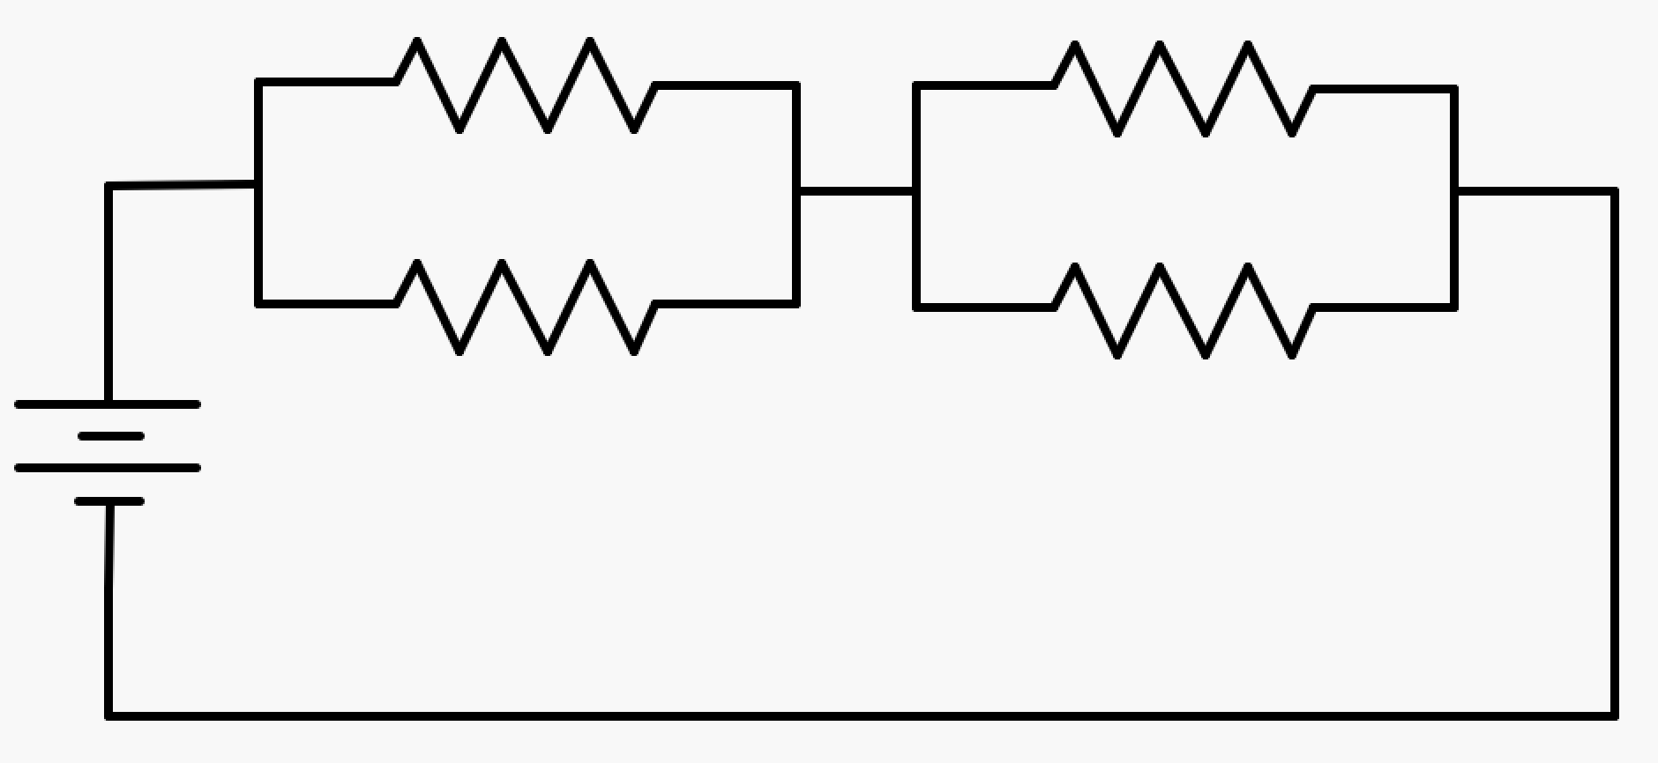

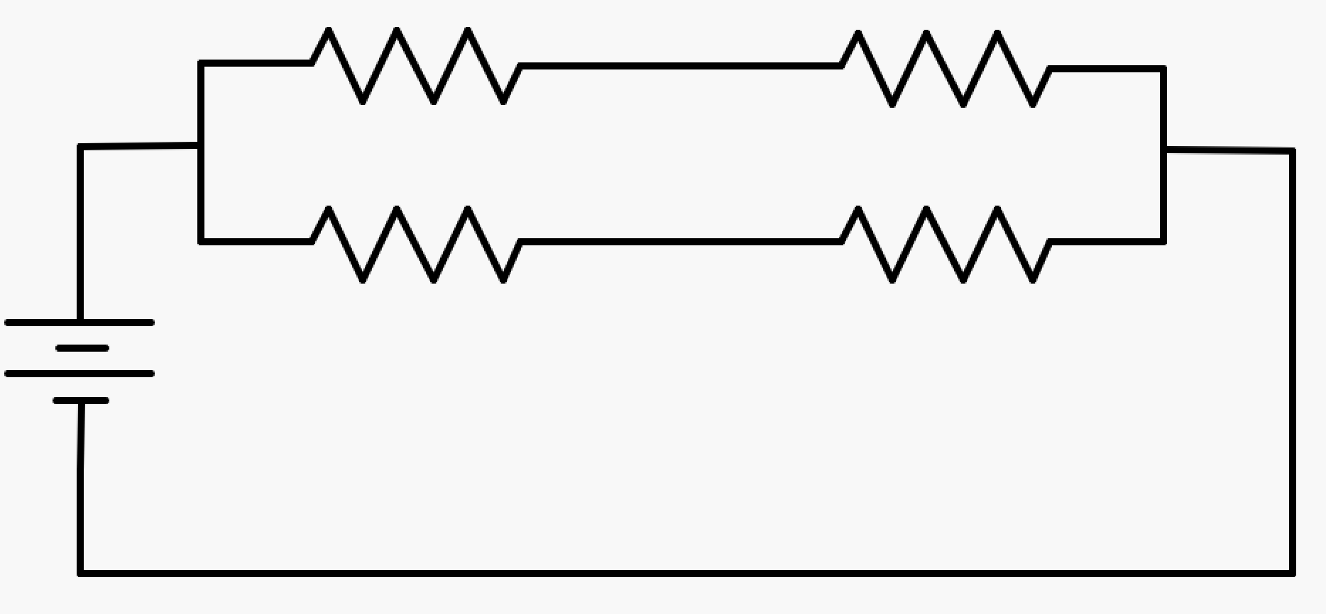

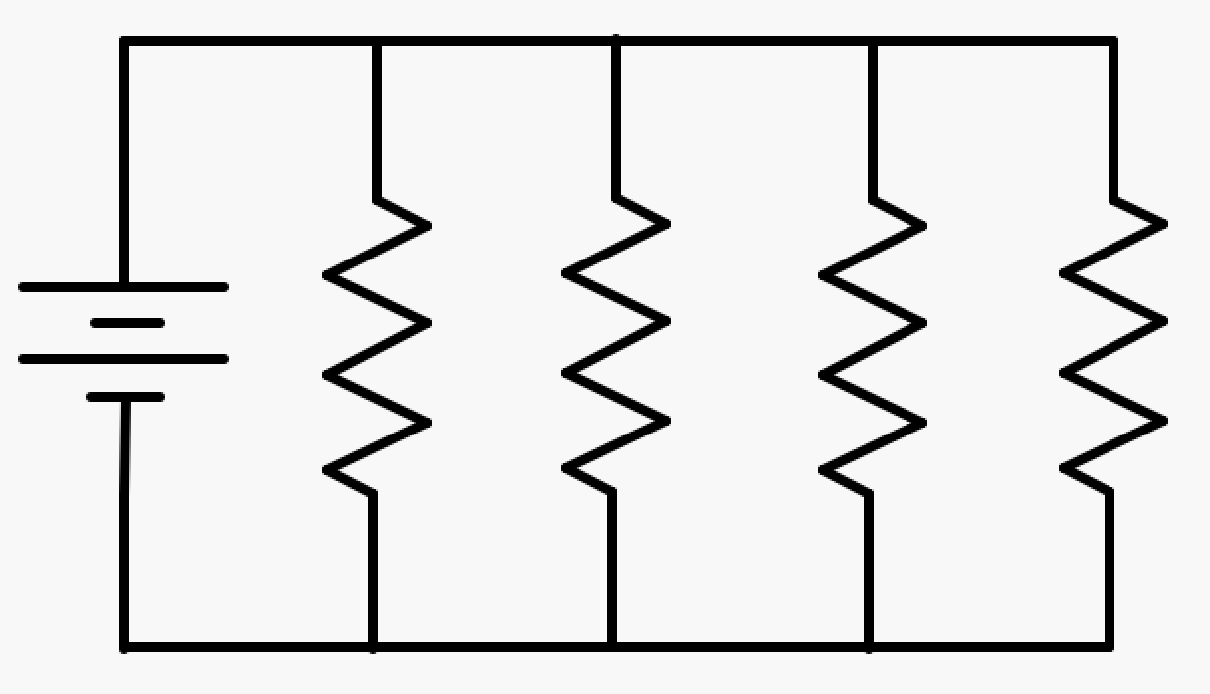
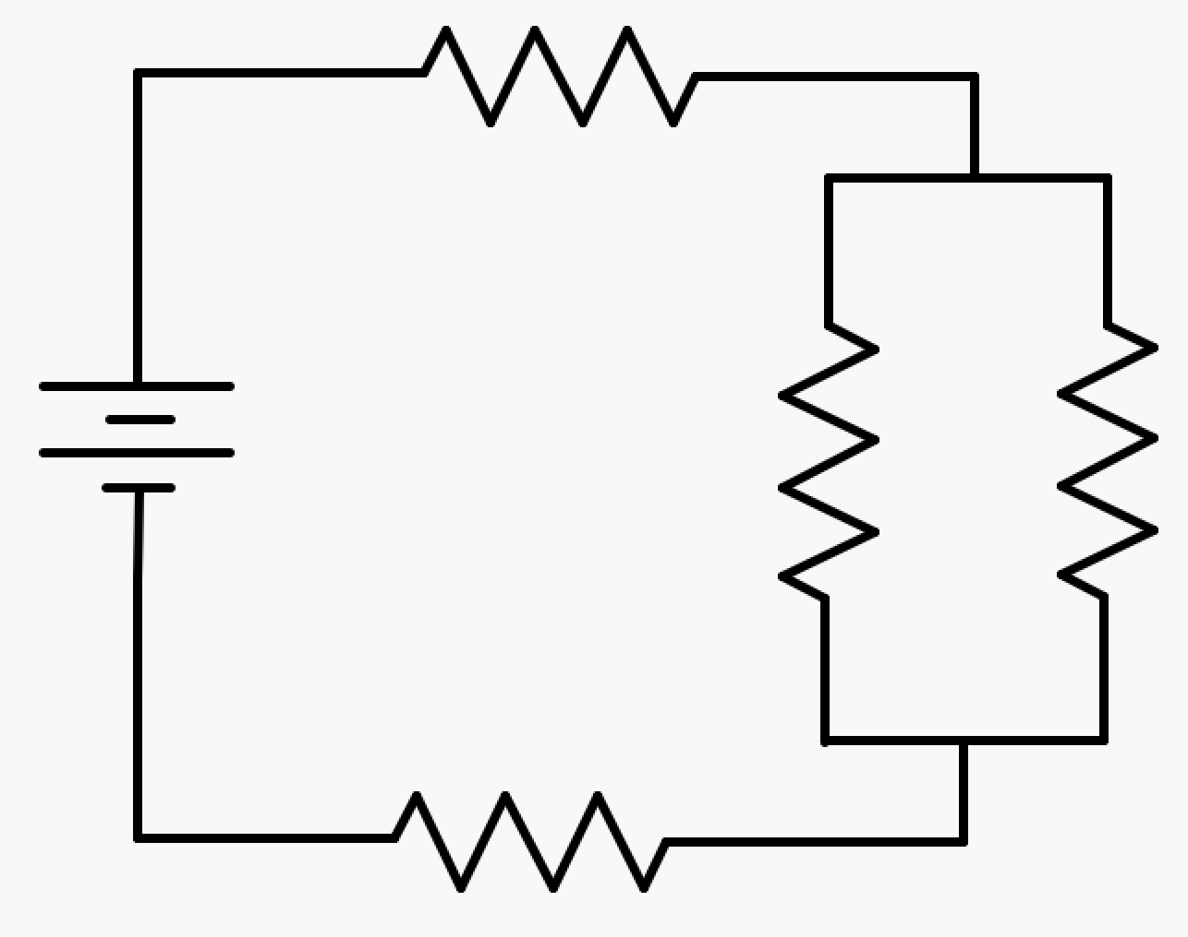

Works Cited
Allain, R. (2014, December 11). What’s the difference between lightbulbs in series and parallel? - YouTube. Retrieved April 18, 2020, from https://www.youtube.com/watch?v=oJS1nXfQGKA
Bohannan, J. B. (2016). Differentiated Instruction: Inclusive Strategies for Secondary Science. Retrieved from http://opensiuc.lib.siu.edu/gs_rp
DiGuieseppe, M., Howes, C. T., Speijer, J., Stewart, C., van Bemmel, H. M., Vucic, R., & Wraight, V. (2011). Physics 11. Toronto, ON: Nelson Education Ltd.
EduGAINS. (2016). Knowing and Responding to Learners – A Differentiated Instruction Educator’s Guide. Retrieved from www.learnteachlead.ca.
Forrester, T., Sandison, C. E., & Denny, S. (2017). Vertical whiteboarding a mathematics classroom. Australian Mathematics Teacher, 73(4), 3–9.
Grace, L. (n.d.). UCSB Department of Physics Lecture Demonstrations Web Page. Retrieved April 18, 2020, from http://web.physics.ucsb.edu/~lecturedemonstrations/
Liljedahl, P. (2015). BUILDING THINKING CLASSROOMS: CONDITIONS FOR PROBLEM SOLVING.
Maeng, J. L., & Bell, R. L. (2015). Differentiating Science Instruction: Secondary science teachers’ practices. International Journal of Science Education, 37(13), 2065–2090. https://doi.org/10.1080/09500693.2015.1064553
Ontario Association of Physics Teachers. (n.d.). Grade 11 Physics Contest. Retrieved April 3, 2020, from https://oaopt.wildapricot.org/contest
Ontario Ministry of Education. (2008a). The Ontario Curriculum Grades 11 and 12 Science, 1–118. Retrieved from www.edu.gov.on.ca.
Ontario Ministry of Education. (2008b). The Ontario Curriculum Grades 9 and 10 Science. Retrieved from www.edu.gov.on.ca.
The Organic Chemistry Tutor. (2019, November 29). Series and Parallel Circuits - Light Bulb Brightness - YouTube. Retrieved April 18, 2020, from https://www.youtube.com/watch?v=NjgxXcBfIII
Tolentino, A. N., & Roleda, L. S. (2017). Learning Physics the Gamified Way. In DLSU Research Congress. Retrieved from https://www.researchgate.net/publication/327869231_Learning_Physics_the_Gamified_Way
Tolentino, A. N., & Roleda, L. S. (2019). Gamified physics instruction in a reformatory classroom context. In ACM International Conference Proceeding Series (pp. 135–140). New York, New York, USA: Association for Computing Machinery. https://doi.org/10.1145/3306500.3306527

