Assessment Ideas

Creating Learning Goals and Success Criteria with the Ontario Science Curriculum

Creating your assessment tool, learning goals, and success criteria from the top down ensures validity and reliability. Here are some examples with the grade 5 curriculum.

1. Start with the MOE document and Overall Expectations:

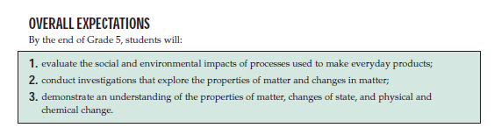

2. Unpack Knowledge and Skills:

Looking at the specific expectations, what are the learning concepts, principles, and information, application to a context:

Overall Expectation | UNPACKED knowledge and skills
demonstrate an understanding of the properties of matter, changes of state, and physical and chemical change. | - matter is all around us - anything that has mass and takes space  - matter is made up of particles called molecules  - 3 different states are solid, liquids, and gas  - Solids have definite volume and hold their shape  - Liquids have definite volume and take the shape of the container they are in  - Gases have no definite volume and take the shape of the container  - states can change and we can see it happen all around us

3. Turn the list of Knowledge and Skills into Learning Goals:
What do YOU want students to know or be able to do? (e.g., We are learning to …)
UNPACKED knowledge and skills | Learning Goals
- matter is all around us - anything that has mass and takes space  - matter is made up of particles called molecules  - molecules of matter can be in different states  - 3 different states are solid, liquids, and gas  - Solids have definite volume and hold their shape  - Liquids have definite volume and take the shape of the container they are in  - Gases have no definite volume and take the shape of the container  - states can change and we can see it happen all around us  - etc... | We are learning...  - That the world around us is composed of matter, which is composed of tiny particles that have different states  - Solid, liquid, and gas are 3 states of matter  - We can change the state of matter by changing the temperature  - There are processes that occur in nature and at home that demonstrate these changes

4. Turn the Learning Goals into Success Criteria:
- Written from their perspectives
- How do students know they are successful?

Learning Goals | Success Criteria
We are learning...  - That the world around us is composed of matter, which is composed of tiny particles that have different states  - Solid, liquid, and gas are 3 states of matter  - We can change the state of matter by changing the temperature  - There are processes that occur in nature and at home that demonstrate these changes | I am able to...  - represent water as tiny particles  - create a program that animates water as solid, liquid, and gas  - show a relationship between the temperature and state of matter  - show that a fridge will freeze water into a solid, that I can obtain liquid water from a room faucet , and that boiling water in a kettle changes it to a gas

Success criteria are essential for two things:
- The giving of descriptive feedback - Assessment FOR and AS learning!
- The development of an assessment tool
- The Achievement Chart is NOT an “Assessment Tool”
  - It’s not specific enough

- The Achievement Chart IS a framework for assessment
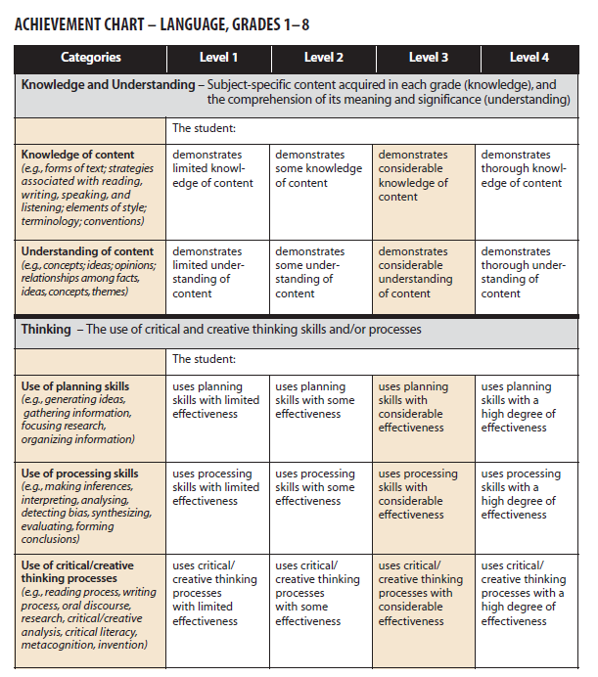
NOT an
“Assessment Tool”
NOT an
“Assessment Tool”
NOT an NOT an
“Assessment Tool”
“Assessment Tool”
NOT an
“Assessment Tool”
NOT

5. Match a standard, Learning Goal or Success Criteria to an achievement chart category:

  - Ensure each criterion is:
    - derived from standards (valid)
    - understood by student (& teacher)
    - observable
    - distinct from each other
    - able to completely describe the whole learning outcomes that the task is intended to access
    - able to be described at different levels

Achievement Chart Categories
Knowledge
See the world around us composed of matter, which is composed of tiny particles that have different states
Communication
Solid, liquid, and gas are three states of matter
Thinking
None
Application
We can change the state of matter by changing the temperature

5. Create Performance-Level Descriptors:

What does student work look like at each level of quality from high to low in this criterion?

 | Level 4 | Level 3 | Level 2 | Level 1
Application  We can change the state of matter by changing the temperature | Each state of matter is accurately represented and gives a clear, detailed, and informative view of what is happening in relation to the temperature | Each state of matter accurately represented in relation to the temperature | Some states of matter do not show what happens in relation to temperature | The representation does not help show what happens to matter in relation to temperature

- Start with Level 3 (Provincial Standard) and move up and down
- Exemplars for different levels - does not have to be task specific
- Descriptors that are too specific constrain creativity and metacognitive development
- Be careful of rubrics disguised as directions (too specific) or checklists (either DONE or NOT DONE)
- Be careful of including quantity to describe different levels - quantity > quality
- Evaluative terms should not be used (e.g., excellent, good, fair, and poor)
- Describe student performance in terms that allow for many different paths to success

Example Rubric for Robotics Task - Grade 4 - Pulleys and Gears

 | Level 1 | Level 2 | Level 3 | Level 4 | Comments
Knowledge and Understanding | Demonstrates a limited understanding of how a pulley and/or gear system allows a small input force to generate a large output force in the context of the robotics task | Demonstrates some understanding of how a pulley and/ or gear system allows a small input force to generate a large output force in the context of the robotics task | Demonstrates considerable understanding of how a pulley and/ or gear system allows a small input force to generate a large output force in the context of the robotics task | Demonstrates thorough understanding of how a pulley and/ or gear system allows a small input force to generate a large output force in the context of the robotics task
Application | Applies at least four of the robotics skills to solve the problem with limited effectiveness | Applies at least four of the robotics skills to solve the problem with some effectiveness | Applies at least four of the robotics skills to solve the problem with considerable effectiveness | Applies at least four of the robotics skills to solve the problem with a high degree of effectiveness
 | Chooses a solution that makes connections between what you know about robotics, science, and the challenge with limited effectiveness | Chooses a solution that makes connections between what you know about robotics, science, and the challenge with some effectiveness | Chooses a solution that makes connections between what you know about robotics, science, and the challenge with considerable effectiveness | Chooses a solution that makes connections between what you know about robotics, science, and the challenge with a high degree of effectiveness
 | Creates a flow chart that proposes a course of practical action of limited effectiveness | Creates a flow chart that proposes a course of practical action of some effectiveness | Creates a flow chart that proposes a course of practical action of considerable effectiveness | Creates a flow chart that proposes a course of practical action of a high degree of effectiveness
Thinking | Uses critical / creative thinking processes to program the robot to complete the chosen plan and accomplish the task, with the parameters (time and space), with limited effectiveness | Uses critical / creative thinking processes to program the robot to complete the chosen plan and accomplish the task, with the parameters (time and space), with some effectiveness | Uses critical / creative thinking processes to program the robot to complete the chosen plan and accomplish the task, with the parameters (time and space), with considerable effectiveness | Uses critical / creative thinking processes to program the robot to complete the chosen plan and accomplish the task, with the parameters (time and space), with a high degree of effectiveness
 | Uses processing skills and strategies to test, troubleshoot, and revise the plan, using the equipment respectfully, with limited effectiveness | Uses processing skills and strategies to test, troubleshoot, and revise the plan, using the equipment respectfully, with some effectiveness | Uses processing skills and strategies to test, troubleshoot, and revise the plan, using the equipment respectfully, with considerable effectiveness | Uses processing skills and strategies to test, troubleshoot, and revise the plan, using the equipment respectfully, with a high degree of effectiveness
Communication | Expresses ideas and information, explaining why and how your solution works, using appropriate scientific and technological terminology with limited effectiveness | Expresses ideas and information, explaining why and how your solution works, using appropriate scientific and technological terminology with some effectiveness | Expresses ideas and information, explaining why and how your solution works, using appropriate scientific and technological terminology with considerable effectiveness | Expresses ideas and information, explaining why and how your solution works, using appropriate scientific and technological terminology with a high degree of effectiveness

Resources:

Wayne Loo and Andrew Schmidt - Presentation on Coding in the Elementary Grades, TDSB, 2014. Used with permission.

Assessment Checklist and Rubric Suggestions

Learning Goals:

Specific Expectations:

 | Consistently | With prompts | Not yet
The student identifies the desired outcome for their design
The student identifies the related QUALITATIVE observations to that outcome
The student identifies the related QUANTITATIVE observations to that outcome
The student uses the vocabulary appropriately
The technological-design process shows signs that new knowledge was used to improve on the design (especially enabling qualitative and quantitative observations)

Assessment Checklist
 | Consistently | With prompts | Not yet
The student can identify which materials are better (taking into consideration all criteria for success)
The student has reworked the design or confirmed their choices following the experimental results
The student follows safety protocols at all times

OVERALL SUGGESTIONS FOR THE UNIT

General Criteria to look for in Assessment Pieces:

 | Consistently | With prompts | Not yet
Can the student use the vocabulary appropriately?
Does the technological-design process show signs that new knowledge was used to improve on the design?
Can the student justify choices in their design for criteria success?

Self-evaluation for design and re-design

Self-evaluation for design and re-design

(5= My best effort; 3 = Medium; 1 = Poor effort)

Were my sketches clear enough for others to understand? | 5 4 3 2 1
Did I include written suggestions on my rough sketch? | 5 4 3 2 1
Did my product do what I designed it to do? Did my solar oven meet my self-selected criteria? | 5 4 3 2 1
If I worked with others, how well did I cooperate? | 5 4 3 2 1
If I worked with others, how would I rate my contribution to the product? | 5 4 3 2 1

Science and Technology Performance Task (From the Halton District School Board)
CRITERIA | Performance Indicators
 | Level 1 | Level 2 | Level 3 | Level 4
Design Process plan | Develops a plan with limited clarity and a few steps | Develops a workable plan with some clarity and some steps | Develops a clear workable plan, including steps, in a logical sequence | Develops a workable plan and modifies the plan as necessary
Design Process use of materials | Uses tools, equipment, and materials with limited regard to safety | Uses tools, equipment, and materials with some regard to safety | Uses tools, equipment, and materials safely | Uses tools, equipment, and materials safely and appropriately
Design Process use of design process | Demonstrates little use of the design process (plan, build, test, evaluate, communicate) | Demonstrates some use of the design process (plan, build, test, evaluate, communicate) | Uses the design process (plan, build, test, evaluate, communicate) | Uses the design process (plan, build, test, evaluate, communicate) effectively
Model  translate plan to model | Translates design plans into a working model, with assistance | Translates design plans into a working model with limited assistance | Successfully translates design plan into a working model based on criteria required | Successfully translates design plan into a working model based on criteria required
Model  model performs intended task | Creates model that performs intended function in a limited manner | Creates model with some evidence of intended function | Creates model that functions successfully according to specifications | Creates model that functions beyond expectations
Communication terminology | Uses little appropriate terminology for grade level | Uses some appropriate terminology for grade level | Uses most appropriate terminology for grade level | Uses all appropriate terminology for grade level
Communication clarity | Report lacks clarity | Communicates with some clarity | Communicates clearly, precisely (e.g., oral or written) through all stages of task | Communicates clearly, precisely, and insightfully
Communication presentation skills / style | Limited awareness of importance of style to suit purpose | Uses a presentation style that is somewhat appropriate to purpose and audience | Chooses a presentation style that is appropriate to purpose and audience | Skillfully chooses a presentation style that maximizes the impact for purpose and audience
Communication of basic concepts | Communicates understanding of few of the basic concepts | Communicates understanding of some of the basic concepts | Communicates understanding of most of the basic concepts (for grade level) e.g., oral or written | Communicates understanding of all of the basic concepts
Learning Log reflection for purpose | Makes limited reflection | Reflects on results but makes few changes | Reflects on results in order to make necessary changes and evaluate information gathered | Uses sophisticated reflection to record results. Makes changes and evaluates information gathered
Learning Log goals / time lines | Sets a few goals and describes few of the steps needed to achieve goals | Sets some goals and describes some of the steps needed to achieve goals | Sets clear goals and describes each step needed to achieve goals | Sets clear goals and describes each step needed to achieve goals and adjusts as necessary
Learning Log resources | Selects, records, and uses resources with limited appropriateness | Selects, records, and uses somewhat appropriate resources | Selects, records, and uses appropriate resources | Selects, records, and integrates appropriate resources
Group Work contribution to group goal | Has limited success working toward group goals | Demonstrates some commitment to the group goals; carries out specific roles with some success | Demonstrates commitment to the group goals and carries out assigned roles | Actively identifies group goals and fulfills a variety of roles in group

Sample Design Rubric

Categories↓ | Needs Improvement  1 | Fair  (Novice)  2 | Good  3 | Excellent  4
Innovative Design  (program and structure in unison) | Design is substandard; not able to achieve the challenge; motor movement is inaccurate; misuse of sensors | Design is standard with no surprises or innovation; achieves the challenge at least some of the time; standard use of sensors | Some unique features that make the design better than average; achieves the challenge all or almost all of the time; thoughtful use of sensors | The design is surprisingly unique, making it superior to others; achieves the challenge every time; superior use of sensors
Structure | Structure is fragile, falling apart under normal use | Structure often holds together under normal use, but is cumbersome or inefficient | Structure is strong and efficient; almost always holds together under normal use | Structure is both solid and elegant; holds up against mishandling
Program | Program unable to complete the challenge; not linked to sensors; illogical | Program often completes the challenge, but inconsistently, inaccurately, or taking more time than needed | Program is logical and efficient; achieves the challenge all or almost all of the time | Program is surprisingly sophisticated; achieves the challenge all of the time

Self-evaluation for SPICE Model

1. Were my sketches clear enough for others to understand?

 | 1 | 2 | 3 | 4 | 5
2. Did I include written suggestions on my rough sketch?
 | 1 | 2 | 3 | 4 | 5
3. Did my product do what I designed it to do?

 | 1 | 2 | 3 | 4 | 5
4. If I worked with others, how well did I cooperate?

 | 1 | 2 | 3 | 4 | 5
5. If I worked with others, how would I rate my contribution to the product?

 | 1 | 2 | 3 | 4 | 5
(5= My best effort; 3 = Medium; 1 = Poor effort)

Accommodations and Modifications

Accommodations

- Allow access to the video provocations before and after lesson for developing background knowledge and review
- Have students work in groups or partners for research and design challenges
- Chunk the list of steps and include visuals to assist in completing the design challenges
- Allow students more time to complete the task
- Allow students to suggest another platform (to build on or to program with) or group of materials for completing the task to utilize students’ prior knowledge
- Reduce the complexity of the challenge (i.e., reduce number of success criteria)

"Growing Success: Assessment, Evaluation, and Reporting in Ontario's Schools, First Edition Covering Grades 1-12", 2010) http://www.edu.gov.on.ca/eng/policyfunding/growSuccess.pdf

Modify an expectation for this activity based on student’s IEP
- E.g., Grade 8 language expectation, Writing strand: (Students will) write complex texts of a variety of lengths, using a wide range of forms.
- Modified expectation: (The student will) write patterned short texts using specified forms.

