SCH4U: Electrochemistry

Student Activity: Reaching Your Potential – Building a Battery
Topics  Galvanic Cells  Cell Potential | Timing  preparation: 30 minutes  demonstration: 15-30 minutes  activity: 30 minutes

Specific Expectations: SCH4U

Introduction
This activity introduces students to the concept of building a galvanic cell and generating a cell potential (or voltage) from a battery of galvanic cells connected in series. The galvanic cell used involves two readily accessible metals and an easily prepared electrolytic solution. Assembling several galvanic cells in series makes a battery.

Materials (per group of students)
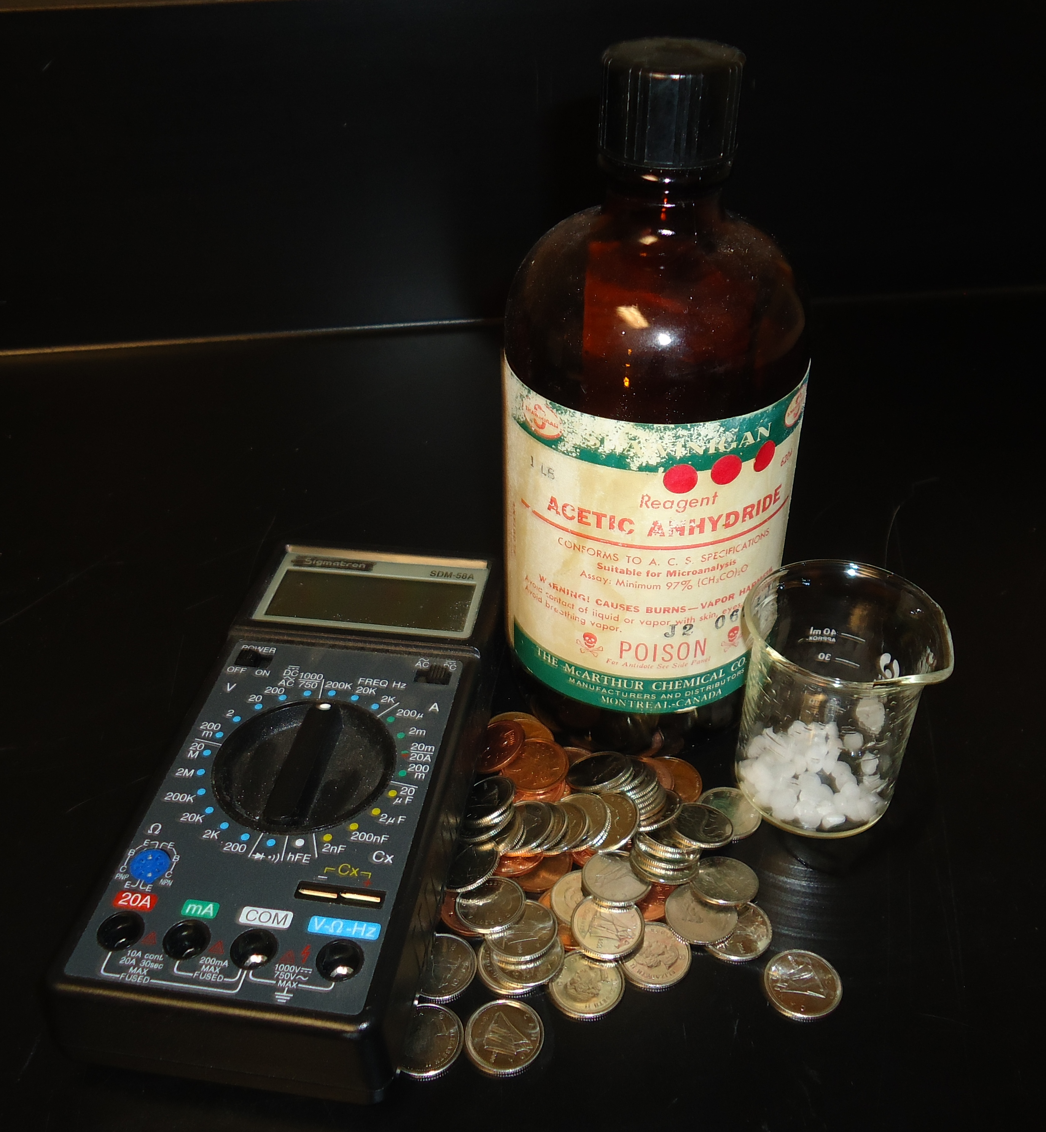
salt (sodium chloride)
vinegar
one 400 mL beaker (with about 200 mL of water)
paper towel
massing scale
20 nickel coated dimes
20 copper coated pennies
low voltage voltmeter with leads with clips
splash goggles
have gloves available for students with sensitivities

Safety Considerations
Wear splash goggles.
Do not ingest any of the materials used in the demonstration/activity.
Offer gloves to students who are sensitive to contact with chemicals.

Hazardous Materials Identification System Rating
(0-minimal 1-slight 2-moderate 3-serious 4-severe)
Vinegar  HMIS (0 to 4)  Health 1  Fire Hazard 0  Reactivity 0 | Sodium chloride (salt)  HMIS (0 to 4)  Health 1  Fire Hazard 0  Reactivity 0

Procedure
Preparation
- Organize students into small groups.
- Ask the groups to assign a student to gather all necessary materials and equipment.
- Instruct the group to assign a student to prepare an electrolytic solution by dissolving approximately 5g of salt in a solution of 200mL of water mixed with 50mL of vinegar.
Predict/Explain
- Instruct student groups to predict how the number of coins and the order of the coins will affect electric current. The prediction must be supported by an explanation.
Observe
- Ask the group to prepare 15-20 pieces of paper towel by cutting them to 1cm x 1cm dimensions. Soak the pieces of paper towel in the electrolytic solution.
- Place a penny on the surface of the bench. Place a piece of the soaked paper towel on the penny. Place a dime over the wet paper towel.
- Test and record the potential (voltage) by connecting a voltmeter to the top dime and bottom penny of the cell.
- Continue to build the additional cells until you have 15-20 penny-dime layers. The result will be a cylindrical series of penny-paper towel-dime layers.
- Apply a small amount of pressure on the top of the cylinder with your finger. Remove any excess paper towel that is hanging out of the cylinder.
- Test and record the potential (voltage) by connecting a voltmeter to the top dime and bottom penny of the setup.
Explain
- Instruct the student groups to review their earlier predictions and revise their explanations based on the data they have collected.

Disposal
The pennies and dimes can be cleaned and reused in future demonstrations/activities.
Used paper towel can be thrown in the garbage.
Dispose of solutions following the protocol established by the employer.

What happens?
The alternating coin structures provide an electric potential (voltage).
Typically, as the number of individual penny-paper towel-dime cells increases, the measured electric potential (voltage) goes up.
The potential (voltage) produced is low (~0.1-0.5 V).

How does it work?
A battery is composed of a series of galvanic (or electrochemical) cells. A galvanic cell produces a flow of electrons (or electric current) due to an electron transfer (or reduction-oxidation (redox)) reaction. In a redox reaction, one substance is reduced (meaning it gains electrons) and one substance is oxidized (meaning it loses electrons).
When a spontaneous redox reaction is set up, one can convert the chemical potential energy into electrical energy. To create a useful electrochemical cell, one needs to use a spontaneous redox reaction and the two substances need to be separated yet it is necessary to provide a conductive medium within which the electrons can flow.
In the battery built in this activity there are several cells connected in series. Each cell is composed of a penny/electrolyte/nickel. The copper plating on the penny undergoes reduction and the nickel-plating on the dime undergoes oxidation. The paper towel soaked with a mildly acidic and salty solution provides the electrolytic medium.

Teaching Suggestions/Hints
Students follow a prescriptive procedure. Use this as a stepping point for helping them understand the electrochemical interaction of chemicals in a reaction so that they can then start to pose questions for a new investigation.

Next Steps
Consider the substitution of other materials for the materials presented. Encourage students to consider alternative electrolyte solutions (such as lemon juice) or different coins (see Additional Resources below for assistance related to selecting coins).

Students could explore the composition of other types of batteries (eg. Alkaline batteries, Ni-Cd batters, Li batteries, etc.) and discuss the advantages and disadvantages.

Additional Resources
- This activity write-up has some useful pictures of the setup: http://www.how-things-work-science-projects.com/coin-battery.html
- Refer to this site to ensure that the coins you select match the requirements: http://www.bcscta.ca/resources/hebden/chem/Coin%20Compositions.pdf

Specific Expectations

SCH4U
A1.5 conduct inquiries, controlling relevant variables, adapting, or extending procedures as required, and using appropriate materials and equipment safely, accurately, and effectively to collect observations and data

F2.4 build a galvanic cell and measure its cell potential
F3.2 identify the components of a galvanic cell, and explain how each component functions in a redox reaction

Return to top

