## SCH4U: Organic Chemistry

# Student Activity: Diaper Dissection

|  |  |
| --- | --- |
| Topics Polymers  Sodium polyacrylate | Timing preparation: 30 minutes  demonstration: 30-45 minutes |

## Specific Expectations: SCH4U

## Introduction

This activity introduces students to a consumer product that has many different types of polymers. Students will dissect a disposable diaper and take note of different types of polymers used in this consumer product. They will focus on the use of sodium polyacrylate as an absorbent used in disposable diapers. This activity can be used as an introduction to the polymers component of the organic unit or it could launch a discussion on the use of disposable consumer products.

## Materials (per group)

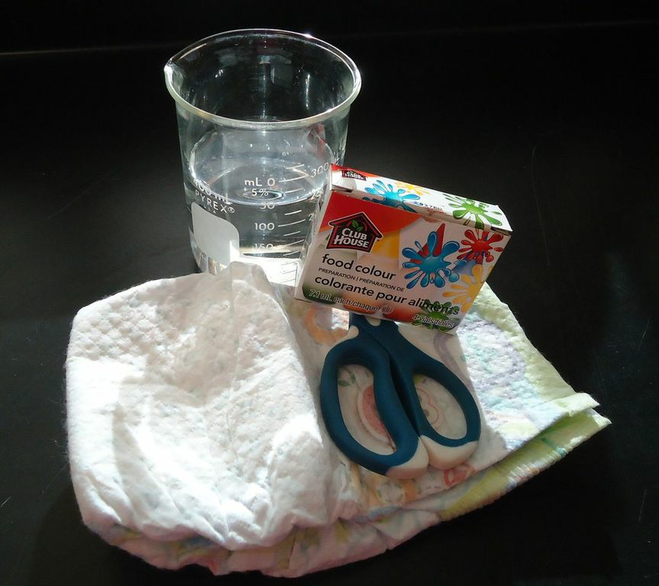

one disposable diaper

one pair of scissors

one 400 mL beaker (with approx. 200-250 mL of water – food colouring is optional)

one large re-sealable plastic bag

10 mL graduated cylinder

500 mlL beaker

table salt, calcium chloride, sugar

safety goggles

gloves

## Safety Considerations

Wear eye protection and gloves.

Respirator masks can reduce the risk of inhaling airborne crystals.

Do not ingest or inhale polyacrylate crystals or touch face/eyes while handling the crystals with a gloved hand – they cause dehydration and/or irritation.

Wash hands after the activity is completed.

Polyacrylate may irritate a person with sensitivities.

## Procedure

**Preparation**

1. Organize students into groups of no more than four people.
2. Ask students to assign one student to gather materials for the group.
3. Explain that there are some hazards connected with materials inside the diaper and instruct groups to assign a student to collect Personal Protective Equipment (PPE) that must be worn by all students.

**Predict/Explain**

1. Ask the groups to predict the physical traits of material in the diaper. Students must include an explanation to support this prediction.

**Observe**

1. Ask students to use their sense to make and record their observations about the intact diaper.
2. Instruct students to list the different identifiable parts on the intact diaper.
3. Instruct students to use scissors to cut through the layers of the diaper where it is thickest and pull the diaper apart.
4. Ask students to identify the different layers and parts of the diaper. Describe what they see and feel for these different layers, including different films and adhesives of the diaper.
5. Instruct students to focus release the cotton layers of the diaper from the rest of the diaper.
6. Place the cotton layers inside the re-sealable plastic bag. Seal the bag.
7. Inform students how to discard the rest of the diaper materials.
8. At this point, have students review their earlier prediction and give more detail to the type of material to be found in the cotton layer inside a diaper. Ask students to back up their predictions with a substantive explanation.
9. Have students shake the bag with the cotton layers vigorously in order to dislodge and isolate the small white crystals of sodium polyacrylate. Accumulate the crystals in one corner of the bag.
10. Shake the bag more until much of the sodium polyacrylate has been isolated.
11. Open the re-sealable plastic bag and discard the cotton layer in the trash.
12. Transfer the sodium polyacrylate crystals into a 500 mL beaker.
13. Instruct students to use the 10 mL graduated cylinder to slowly add water to the beaker, recording the amount added.
14. Observe and record any observable changes.
15. Add water until the material is saturated, noting the amount of water that was added.
16. When all groups are done, have them share how much water was absorbed.

**Explain**

1. Ask students to provide an explanation for what is happening when water is absorbed by the sodium polyacrylate.

## Disposal

All materials can be thrown in the garbage. Where appropriate, the re-sealable plastic bags can be recycled.

## What happens?

Students separate a number of different structures with different properties and functions:

|  |  |
| --- | --- |
| **Diaper Structure Found** | **Material Used** |
| water proof films coat the diaper | polyethylene |
| stretchy substances for cuffs and waistbands | polyurethane, rubber, Lycra |
| softer substance for comfortable fit | polypropylene |
| adhesives and glues | various materials |
| Cotton layers with crystals to absorb liquids | cotton and polyacrylate crystals |

Keeping the polyacrylate in the bag reduces the risk of inhaling these crystals. When water is added, the crystals grow in size. The texture changes from a crystal to gel.

## How does it work?

Sodium polyacrylate is an example of a condensation polymer. On it’s own, it is tightly would and appears like a granule of sugar. The monomer of sodium polyacrylate looks like this

[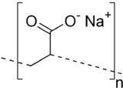](http://www.google.ca/url?sa=i&rct=j&q=sodium+acrylate+monomer&source=images&cd=&cad=rja&docid=wSYprTIKE-DIYM&tbnid=KyjH4hHK-kYGRM:&ved=0CAUQjRw&url=http://en.wikipedia.org/wiki/Sodium_polyacrylate&ei=H_KrUdHbNcrhqQHqhoHIAw&bvm=bv.47244034,d.aWc&psig=AFQjCNFORGyn8qjJ1Fy2y4HAXJC7v9GTUQ&ust=1370309520302307)

When water is added, the polyacrylate will absorb the water through osmosis and hydrogen bonds with the oxygen in water. As this occurs the polyacrylate molecule will unwind and become larger. (see image below)Sodium polyacrylate is capable of absorbing up to 200-300 times its mass in water.

[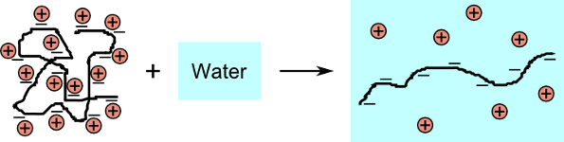](http://www.google.ca/url?sa=i&rct=j&q=sodium%20polyacrylate%20dry%20and%20wet%20forms&source=images&cd=&cad=rja&docid=qaL_aMKP6P19uM&tbnid=F6Nghc0COa2CiM:&ved=0CAUQjRw&url=http://www.bss.phy.cam.ac.uk/~nb394/miscellaneous/superabsorbent_polymers/&ei=V_KrUYyVK4fyqQGk_YG4Bw&bvm=bv.47244034,d.aWc&psig=AFQjCNH65TNszwULIZg3yiMtTkFEIbSJZw&ust=1370309582255369)

## Teaching Suggestions/Hints

Ask students to make a poster or presentation that outlines the structure of the diaper based on their observations.

Use the experiences from this activity to review the molecular activity of polyacrylate and water, with an emphasis on the nature of the polymer.

Ask students to research the make a product comparison of different diaper brands to learn how they are similar and different.

Challenge students to design a better diaper that improves performance for a better price.

## Next Steps

There are many possible next steps to this activity. Students could discuss and debate the use of disposable diapers versus natural cloth diapers. One could dig deeper into the composition of sodium polyacrylate and highlight the features of a condensation polymer. Finally, students could perform more quantitative experiments measuring the amount of water absorbed or the effect of additives such as sodium chloride or calcium chloride.

## Additional Resources

1. Here is a more detailed listing of all the materials in a typical disposable diaper: <http://disposablediaper.net/faq/what-are-the-components-of-a-typical-disposable-diaper/>
2. Steve Spangler’s Insta Snow product (promotional video): <http://www.youtube.com/watch?v=VkfvpMyjeBI>
3. A YouTube video of the addition of water into sodium polyacrylate: <http://www.youtube.com/watch?v=Vais8pL0w8U>

## Specific Expectations

## SCH4U

## A1.5 conduct inquiries, controlling relevant variables, adapting or extending prodceudres as required, and using appropriate materials and equipment safely, accurately, and effectively to collect observations and data

## B1.1 assess the impact on human health, society, and the environment of organic compounds used in everyday life (e.g., polymers, nutritional supplements, food additives, pharmaceuticals, pesticides)

Return to top