SCH3U: Gases and Atmospheric Chemistry

Teacher Demo: An Eggciting Demonstration!
Topics  Atmospheric Pressure  Simple Gas Laws | Timing  preparation: 30 minutes, including time to hard boil egg  demonstration: 15 minutes

Specific Expectations: SCH3U

Introduction
This demonstration is a dramatic look at the influence of the atmospheric pressure and the relationship of pressure and temperature of a gas. A burning piece of paper is inserted in a bottle and an egg is set on top of the bottle. After the flame is extinguished the egg is sucked (or pushed!) into the bottle.

Materials
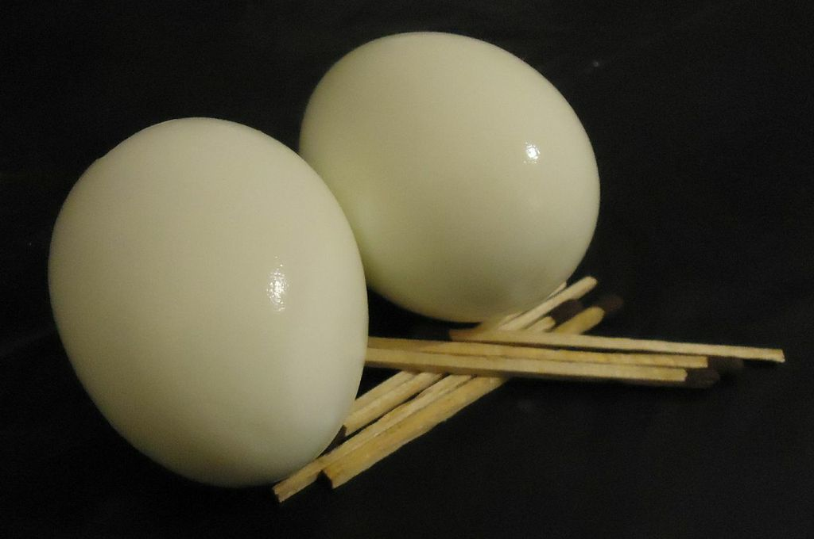
2-3 peeled, hard-boiled eggs (appropriate size for the glass jar mouth)
a thick-walled glass jar, bottle or flask (old glass milk containers work well as do larger Erlenmeyer flasks)
small piece of paper
matches or a lighter
face shield
sand bucket and/or fire extinguisher

Safety Considerations
Wear eye protection. A face shield provides the greatest protection. Inspect the glass container to determine that there are no cracks or weaknesses. A low pressure will be created in the glass container and it could break.
Proper attention should be paid towards fire safety. All long hair should be tied back during this demonstration.
Use a safety shield in case the glass jar breaks. Instruct students to stay some distance back for their own safety.

Procedure
Predict/Explain
- Instruct students to work in pairs. They will keep a record of their thoughts and observations.
- Outline the procedure: a burning piece of paper is placed in the glass container and an egg is placed over the seal of the container.
- Ask each pair to make and record a prediction and back up this prediction with an explanation. They may want to include a diagram.
Observe
- Light a piece of paper on fire.
- Carefully place the piece of burning paper into the glass container.
- Set a peeled hard-boiled egg on top of the bottle while the paper is burning.
- Lightly hold the egg to the mouth of the glass container.
- After the combustion of the paper is complete, observe.
Explain
- Ask students to revisit their predictions and explain any differences.

Disposal
Do not ingest the egg after use.
The egg can be composted or thrown in the garbage.
The clean jar can be reused or recycled.

What happens?
After the burning piece of paper extinguishes, the egg will slowly (or sometimes quickly) get sucked into the glass container.

How does it work?
The piece of burning paper in the glass container heats up the air particles inside. The movement of these particles raises the pressure of the gas in the container, pushing up the egg slightly. This is why the egg needs to be lightly held to the glass jar as the fire burns. A tight seal ensures that no new air particles enter the jar.
Once the fire has gone out, the temperature decreases and the air particles slow down. The pressure of the gas inside the glass container becomes lower than the pressure outside the glass container. As a result, the atmosphere pushes the egg into the glass container.

Teaching Suggestions/Hints
Ask students to devise a procedure to remove the intact egg from the container. It can be done by changing the conditions and increasing the pressure inside the bottle. This can be done by blowing air inside the glass container and then quickly settling the egg over the opening.

Ask students to consider the notion of vacuum action as a process for moving materials.
For example, the Vactrain is a proposed transit system that uses magnetic levitation within near vacuum tube environments.

Next Steps
There are many possible next steps to this activity. This demonstration could lead into a quantitative study looking at the relationship between pressure and temperature of a gas (with a constant volume). This study can lead to the graphical analysis of pressure versus temperature and the extrapolation of data to find absolute zero.

As well, there are modifications possible including a version presented by Steve Spangler that uses small candles placed on the egg. See the Resources section for further details.

Additional Resources
- Additional methods and explanations: http://chemistry.about.com/od/chemistrydemonstrations/a/egginabottle.htm
- Steve Spangler’s new twist on the classic Egg in a Bottle Demo: http://www.stevespanglerscience.com/lab/experiments/egg-in-bottle

Specific Expectations
SCH3U
A1.1 formulate relevant scientific questions about observed relationships, ideas, problems, or issues, make informed predictions, and/or formulate educated hypotheses to focus inquiries or research
F3.3 use the kinetic molecular theory to explain the properties and behaviour of gases in terms of types and degrees of molecular motion
F3.4 describe, for an ideal gas, the quantitative relationships that exist between the variables of pressure, volume, temperature, and amount of substance

Return to top

