SBI3C: Anatomy of Mammals

Teacher Demo: From Gums to Bums
based on a demo of the same name by Vittorio Iafrate, OCT (BEd OISE 2010)

Topics  digestive system | Timing  preparation: 30 min  demonstration: 15-20 min

Specific Expectations: SBI3C

Introduction
This demonstration uses food and a series of containers and additives to model the process of mechanical and chemical digestion in the human (mammalian) digestive system. The demonstration begins with actual food items and ends with a paste closely resembling fecal matter. Due to the high “gross” factor, this demo is a hit with students and is guaranteed to be very memorable.

Materials
six clear washing bottles
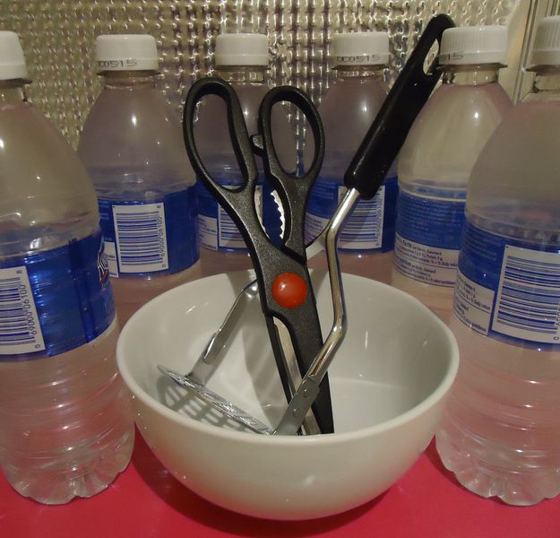
three large bowls
two large buckets
one potato masher
one pair of scissors
various food items*
water to fill the 6 squirt bottles
one small vial each of red and green food colouring
two clear plastic bags
one pair lab gloves
one pair safety goggles
one large sponge
5 mL brown water-based paint
newspapers/newsprint/paper towels (for clean-up)
11 labels (permanent marker on masking tape or label sheets): enzymes, saliva, mouth, small intestine, large intestine, blood, toilet, stomach acid, bile salts, bile pigments, sodium bicarbonate
*such as starch (a piece of bread), fruit/vegetable (a soft pear), a protein (20 g tofu)

Safety Considerations
Ensure students are not allergic to food items chosen.
Do not ingest any of the food items before, during, or after the demonstration.
Wear gloves and splash goggles during the preparation and demonstration.
Wash hands thoroughly after this demonstration is complete.

Procedure
Preparation
- Make 6 labels for the washing bottles: saliva, enzymes, stomach acid, sodium bicarbonate, bile salts, bile pigments
- Stick one label to each washing bottle
- Make 3 labels for the bowls: mouth, small intestine, large intestine
- Stick one of these labels to each bowl
- Make two labels for the buckets: toilet, blood
- Stick one of these labels to each bucket
- Stick the following labels on the 2 buckets: toilet, blood
- Fill the 6 washing bottles with water
- Add 5 drops red food colouring to “enzymes” bottle
- Add 5 drops green food colouring to “bile salts” bottle
- Add one dime-sized drop of brown paint to “bile pigments” bottle
- Cover work surface with newspaper/paper towel
Predict/Explain
- Instruct students to work in pairs to make a preliminary drawing of the digestive system based on prior knowledge.
- Ask students to share their diagrams.
- Instruct pairs to predict the function of the parts they have drawn.
Observe
Bowl #1
- add all food items to bowl #1 (mouth)
- break up food items with the potato masher
- squirt water from “saliva” bottle into bowl and continue to mash food (representing the beginning of chemical digestion)
- manually mix the food and water around in bowl (representing mixing by the tongue)
- pour bowl contents into clear the plastic bag and spin it closed to represent the stomach
Transfer to Bowl #2
- squirt “stomach acid” (wash bottle #3) and enzymes (wash bottle #2) into bag
- manually mash food
- twist bag closed and position it above bowl #2 (small intestine)
- use scissors to cut off one of the bottom corners of bag
- squeeze food out of the bag and into bowl #2 (small intestine)
Bowl #2
- squirt water from wash bottle #4 (sodium bicarbonate), wash bottle #2 (enzymes) and wash bottle #5 (bile salts) into bowl #2 (small intestine)
- manually mix the material together in bowl #2 (small intestine)
- use sponge to soak up some liquid (nutrient rich water) from contents
- squeeze sponge out into bucket #1 (blood)
- squirt water from “bile pigments” (wash bottle #6) bottle into bowl and mix
- transfer bowl contents to bowl #3 (large intestines)
Bowl #3
- use sponge to soak up remaining liquid from bowl contents
- squeeze sponge to add water to bucket #1 (blood)
- transfer bowl contents to unused plastic bag and spin bag closed (representing the rectum)
- position bag above bucket #2 (toilet)
- using scissors, cut off one of the bottom corners of bag
- squeeze contents out of bag and into bucket #2 (toilet)
Explain
- Ask students to review their predictions and revise their notes.

Disposal
Food material can be added to an existing green bin for municipal composting.
Where this does not exist, the material can be added to garbage.
Filter liquids and dispose of the filtrate in the sink. Remaining material is food material.

What happens?
The demonstration models the actions of different parts of the digestive system.
Food enters the mouth where teeth (potato masher) mechanically tear and crush food. The saliva (washing bottle #1) adds enzymes (washer bottle #2) that start the process of starch digestion and help the tongue (teacher’s hand) mix the food more. The tongue then forms the food into a round ball or bolus.
The bolus enters the esophagus. Peristalsis, the rhythmic waves of muscle contraction move the food into the stomach.
In the stomach (plastic bag), the bolus undergoes more mechanical mixing by the contractions of the muscles in the stomach to form chyme. This helps to emulsify fats. Hydrochloric acid (washer bottle #3) helps to activate enzymes (washer bottle #2) that starts the chemical digestion of protein and fat.
In the small intestine, stomach acid is neutralized by sodium bicarbonate (washer bottle #4). Now the other digestive enzymes (washer bottle #2) can be added for chemical digestion of the food. Bile salts (washer battle #5) from the gallbladder enter the small intestine to continue to emulsify fats so that they can be absorbed. Bile pigments (washer bottle #6) are also added to the small intestine from the gallbladder.
The sponge shows that water rich nutrients are absorbed by the small intestine and transferred to the blood.
In the large intestine, water is absorbed and bacteria start the decomposition of material to form the feces that move into the rectum to be evacuated from the body. In the human body, the digestive process takes 24 - 48 hours.

How does it work?
The demonstration uses bowls, bags and buckets to represent the various organs, as well as blood and waste food container (toilet), which feature in the digestive process. Food is manipulated in ways that mimic what happens to food after it is ingested and students gain a more intimate understanding of what actually happens to food inside them and why waste looks the way it does when it comes out of their bodies.

Teaching Suggestions/Hints
- Include some form of bread in food items used, as it looks convincingly like digested food when wetted and mashed.
- Explain the various steps and ask students prompting questions during the demo. Make the demo as unpleasant as possible in terms of food appearance (but at the same time maintaining a fun and joking manner) to make it more memorable.
- If the class is small, students can be assigned a role to play to make this a more interactive experience. Assign washer bottle #2 (enzymes) to a student who then adds enzymes at several steps.
- Have a diagram of the digestive system to share with students. Review digestion basics to consolidate the learning from the demonstration. Provide students with some reference material (like a textbook) so that students can collaborate to identify some of the key enzymes and where they act to digest food.

Next Steps
Modify the demo in ways that could explain different waste consistencies (e.g. include veggies to show how fibre loosens stool, or leave some water unabsorbed to mimic diarrhea, etc.).

Assign student pairs to learn about one over the counter drug that helps the digestive system. Ask the pair to prepare a very brief report about the drug, how it helps the digestive system and what part of the system is targeted.

Additional Resources
- Watch a video of this demo in action: https://www.youtube.com/watch?v=0gY-zXsUYgs
- This is an animation of the digestive system: http://www.dnatube.com/video/8362/Animation-of-the-digestive-system
Specific Expectations

SBI3C
A1.1 formulate relevant scientific questions about observed relationships, ideas, problems, or issues, make informed predictions, and/or formulate educated hypotheses to focus inquiries or research
E3.3 describe the anatomy and physiology of the digestive system (including the mouth, epiglottis, esophagus, stomach, intestines, liver, and pancreas), the mechanisms of peristalsis, absorption, and mechanical and chemical digestion, and the function of the kidneys
E3.4 explain some of the mechanisms of interaction between a mammal’s different body systems (e.g., the exchange of oxygen and carbon dioxide between the respiratory and circulatory systems)

Return to top

