SNC4M: Biotechnology

Teacher Demo: Marshmallow DNA Model
Topics  Visualizing the structure of DNA | Timing  preparation: 5 minutes  demonstration: 15 Minutes

Specific Expectations: SNC4M

Introduction
This demonstration will provide students with a visual representation of the structure of DNA. Students will learn the different components that make a nucleotide, the correct base-pair connection between nitrogenous bases, and visually see the double helix structure of DNA.

Materials
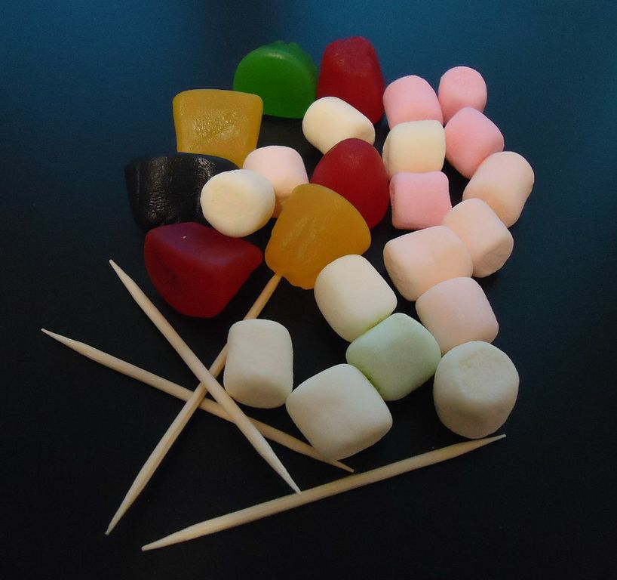
8 green marshmallows – guanine (G)
16 pink marshmallows – adenine (A)
8 orange marshmallows – thymine (T)
4 yellow marshmallows – cytosine (C)
24 white marshmallows – deoxyribose sugars
24 jujube berries – phosphate groups
toothpicks (broken in half) – hydrogen bonds, phosphodiester linkages, and covalent bonds

Safety Considerations
Wear safety glasses to model good practice. The teacher will conduct this demonstration.

Procedure
Preparation
- Start by creating four different types of nucleotides:
- Represent adenine with two pink marshmallows connected to a white marshmallow and jujube berry. Add a half toothpick to the berry, pointing away from the white marshmallow.
- Represent guanine with two green marshmallows connected to a white marshmallow and jujube berry. Add three half toothpicks to the outer marshmallow. Add a half toothpick to the berry, pointing away from the white marshmallow.
- Represent thymine with one orange marshmallow connected to a white marshmallow and jujube berry. Add two half toothpicks to the outer marshmallow. Add a half toothpick to the berry, pointing away from the white marshmallow.
- Represent cytosine with one yellow marshmallow connected to a white marshmallow and jujube berry. Add a half toothpick to the berry, pointing away from the white marshmallow.
Predict/Explain
- Organize students into pairs for this demonstration.
- Hold up an example of each nucleotide for the class.
- Ask them to predict (with a drawing) which nucleotides will connect together for one strand.
- Ask them to predict (with a drawing) how nucleotides will pair across two strands.
Observe
- Create a single-stranded DNA molecule for the following sequence: TACGTATGAAAC by joining the berry (phosphate) of one nucleotide to the white marshmallow (deoxyribose) of the adjacent molecule by connecting the half toothpick (phosphodiester linkage) sticking out from the berry.
- Create the complementary strand to sequence 1 (ATGCATACTTTG) and partner the two strands creating a double stranded DNA molecule by joining the coloured marshmallows (nitrogenous bases) with the appropriate number of half toothpicks (hydrogen bonds) sticking out from the purine marshmallows.
- Twist the DNA molecule to create a right handed double helix.
Explain
- Ask students to review their predictions (drawings) and make revisions as necessary.
- Indicate to students where major groove and minor groove are located in the double helix DNA molecule.

Disposal
All materials can be disposed of in the school’s compost, if not available, place in the garbage.

What happens?
In this demonstration, students will visually see what a DNA molecule looks like. They will be able to determine the different components that makes up a nucleotide (phosphate, deoxyribose sugar, and nitrogenous base), will learn the correct base-pairing of bases in DNA (adenine always bonds with thymine and cytosine always bonds with guanine), will learn how many hydrogen bonds occur between each base pair, and will learn that phosphodiester linkages are formed between phosphate groups and deoxyribose sugars. Students will also be able to identify the major groove and the minor groove in the double helix once the molecule is twisted.

How does it work?
By having the different marshmallows and the jujube berries represent different components of the DNA molecule and the half toothpicks represent various bonds, this demonstration will give students a good visualization of how the DNA molecule is built.

Teaching Suggestions/Hints
- Ensure students have a good understanding of the structure of DNA and are familiar with the causes of the major groove and minor groove in the molecule.
- Students need to be aware of Chargaff’s rule (adenine and thymine always join together with two hydrogen bonds and cytosine and guanine always join together with three hydrogen bonds)
- A good knowledge of the difference between pyrimidines and purines is essential.
- Students are required to know that phosphodiester bonds are formed between phosphate groups and deoxyribose sugars, covalent bonds are formed between deoxyribose sugars and nitrogenous bases, and hydrogen bonds are formed between bases.

Next Steps
Invite students to work in pairs to create a Visual DNA model using the same materials. Students may choose to create their own model to use for review.
This demonstration can be extended to incorporate the visualization of the process of transcription as a step in protein synthesis.

Additional Resources
DNA Structure YouTube Videos:
http://www.youtube.com/watch?v=l-hrLs03KjY&feature=related
http://www.youtube.com/watch?v=qy8dk5iS1f0&feature=related

Specific Expectations

SNC4M
A1.1 formulate relevant scientific questions about observed relationships, ideas, problems, or issues, make informed predictions, and/or formulate educated hypotheses to focus inquiries and research
A1.10 draw conclusions based on inquiry results and research findings, and justify their conclusions with reference to scientific knowledge
F3.2 explain the structure and functions of macromolecules (e.g., DNA, RNA) and the synthesis of proteins

Return to top

