

This activity is suggested for use with the Ontario Curriculum.

Grade 4: Earth and Space Systems

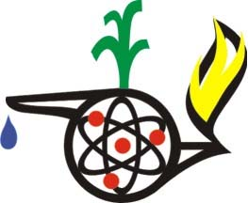

Contributed by: Roberta Oswald

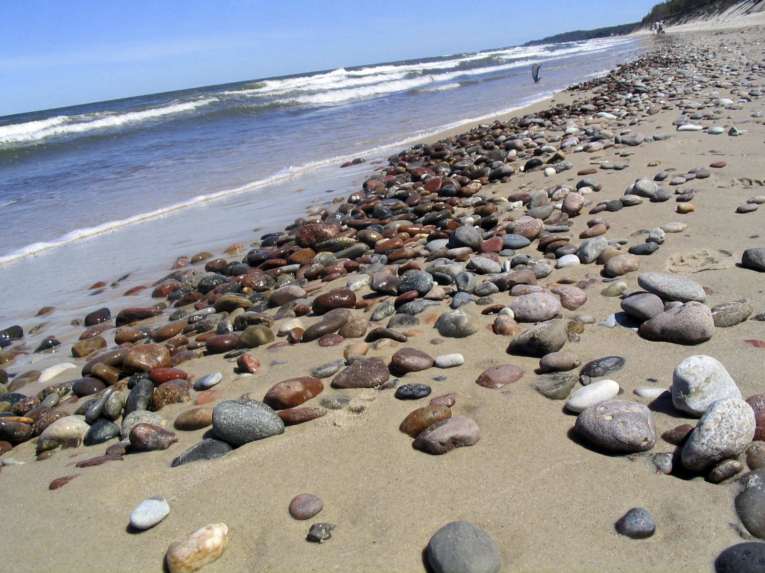

* Demonstrate an awareness of the natural and human-made environment through hands-on investigations, observation, questioning, and sharing of their findings.

Inquiry Skills Used

Ask questions, observe, making inferences and predictions.

Safety Considerations

Wash hands after handling rocks. Make sure there are no sharp edges on any of the materials.

Background

All of us have, at one time or another, reached down to pick up a rock that has attracted us. Whether because of colour or shape, texture or pattern, rocks and minerals seem to call us towards them. There’s a good reason for this. Rocks and minerals are old, ANCIENT, some having been on this Earth for millions, if not billions, of years! Each rock has a story to tell. Having survived a volcanic eruption, been pounded upon by the stampede of a herd of dinosaurs, or witnessed the changes our world has endured in the past hundred years by human exploitation…….oh, if only rocks could talk, the stories they would tell…………

The activity below encourages the use of our senses. As we become better at developing those senses, we also become more aware of the particular properties the specimens have and are better able to make sound predictions.

Before this activity is presented, it is beneficial to have done a few lessons on the different

types of rocks (igneous, sedimentary, metamorphic) and on the differences between rocks

and minerals.

What You Need

* Large container with sand

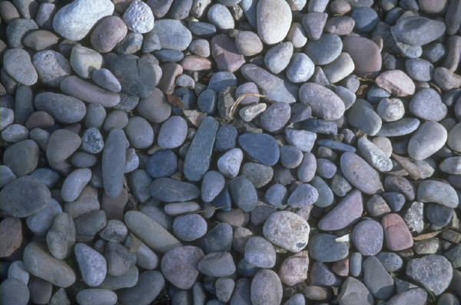

* Variety of rock and mineral specimens
* Cleaning brush
* Rock and mineral identification book or charts
* Bottle of vinegar
* Streak testing kit: ceramic tile
* Hardness testing kit: penny, nail file, mirror,
* Chart of Earth timeline (optional)
* Picture books, stories on rocks

What to Do

1. Begin with a story about rocks to build up the mystery of their age, that they have been on this Earth far

longer than any of us. (*Everybody Needs a Rock* by Byrd Baily, *Pebbles in My Pocket* by Meredith Hooper, *Stone Wall Secrets* by Kristine and Robert Thorson, and *Mountain Dance* by Thomas Locker are but a few choices.)

1. You may also wish to go over an Earth timeline to discuss some of the Earth’s events and the age of rocks.
2. Present a large plastic container filled with sand that has several rocks (and minerals, if you can find any) for each group of students. You may wish to create a bit of a landscape at the top of the sand, to simulate a rocky area, canyon, cliff, etc.
3. Each student, one at a time, is to carefully search through the sand to locate a rock specimen. Once their hand has found one, they are to try to describe it without actually seeing it. Is it rough, smooth, what shape is it, does it feel hard or soft, heavy or light….you may wish to brainstorm a list of potential ‘observations’ before they dig in! Agree on the number of observations the students must make before being able to bring the rock to the surface.
4. Have them make inferences as well, depending on what rock and mineral lessons have come before this activity. For example…my specimen feels very smooth; therefore, I infer that it came from a riverbed or ocean.
5. Once each student has received a specimen, have them share new sight observations with their group. They may also wish to discuss how accurate their original observations were.
6. If possible, allow them to keep their treasures.

Where to Go from Here?

Included with this activity are two identification sheets - one for the 3 different types of rocks, and one on common minerals. Again, to use these to their fullest, you would have done some lessons previously. Depending on the original selection of specimens, the students may use these charts, field guides, and various testing kits to try to identify their treasure. The goal is not so much for the ‘right answer’ as using their observation skills, inferences, and ability to make predictions to attempt to identify their specimen.

STSE Links

How will the hardness of a rock determine what type of rock should be used in construction materials?

Cross Curricular Connections

Language

* After careful observations and discussion of the rocks, students could create a story of where their rock came from, what it has witnessed throughout its life.
* Upon researching their particular specimen, they could create an advertisement on the benefits of their rock type to humankind.

Math

* The class could graph the number of each type of rock or mineral.

Credit Where Credit is Due

The above activities were in part inspired by *Science is…* by Susan Bosak. In fact, you will discover many related activities in her book to help with identification. The two charts presented below were modified from charts in this book.





