

...a really down to Earth topic!



This activity is suggested for use with the Ontario Curriculum.

Grade 3: Earth and Space Systems

Contributed by: Susan Tompkins

* The composition, characteristics, and condition of soil determine its capacity to sustain life.
* Soil is an essential source of life and nutrients for many living things.

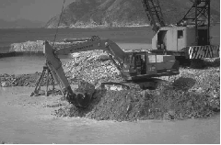

Inquiry Skills Used

This is a research activity where students will explore, investigate, and report.

Safety Considerations

Be aware of student allergies. Ensure students wash their hands thoroughly following the activity.

Background

In this activity, students will observe a variety of soil types and describe the characteristics of these soils. Soil is made up of air, water, recycling organisms, rock particles, and humus. Different types of soils are defined by the different proportions of humus and rock particles they contain. Humus is formed from the decomposition produced by recycling organisms. The three types of rock particles are sand, silt, and clay.

What You Need

* 4 or 5 samples from different areas (e.g., forest floor, garden, beach, playground, etc.)
* Label for each sample

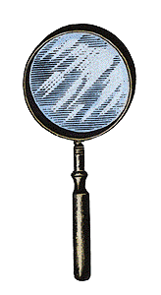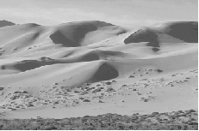

* Sheet of newspaper for each soil sample
* Magnifying glasses

What to Do

1. Divide the class into small groups (4-6 students per group).
2. Provide each group with different labelled soil samples and magnifying glasses.
3. Invite the students to examine the soil samples and consider the following questions:

* What sizes are the rock particles?
* Are there stones, roots, or small animals?
* What colour is the soil?
* What does the soil smell like?
* What does the soil feel like?
* Does the soil stick together?

1. Ask students to create a chart to record their observations.

Where to Go from Here?

Estimate the proportion of the particles that make up the different soil samples. Fill a glass jar or clear plastic container (with lid) 3/4 full with one soil sample. Fill the remaining part of the jar with water. Shake well and let it settle overnight. The next day, observe the different layers that have formed. The particles in the soil should settle from heaviest to lightest. Sand particles will settle first followed by silt, clay, and humus. The students should see the smaller pieces settling in between the larger pieces.

Students can observe the layers and estimate the proportions of the different particles in each soil sample.

STSE Links

How does different soil affect people’s ability to build?

If we continue to cover the soil with asphalt and cement, will we choke the life out of the environment?

Cross Curricular Connections

Mathematics

* This activity also incorporates charting and data management when the students collect and chart data.

Credit Where Credit is Due

Adapted from *Science Is...A Source Book of Fascinating Facts, Projects and Activities* by Susan V. Bosak.