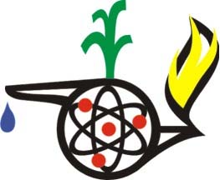
Contributed by: Gordon Webb

This activity is suggested for use with the Ontario Curriculum.

Grade 2: Earth and Space Systems

- Changes to air and water affect living things and the environment.

- Air and water are a major part of the environment.

Inquiry Skills Used
This is a research activity with students using observation and data collection.

Safety Considerations
Even though this is an incredibly safe activity, it provides a great opportunity to model safety practices, such as using our senses safely when observing, and working carefully. If using warm water, caution the students about the water temperature. If using a heat lamp, then caution the students not to touch the heat source.

Background
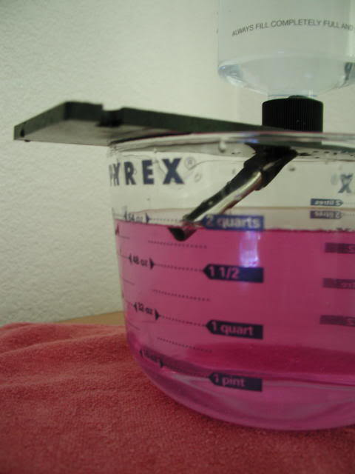Many children can identify that water exists in 3 states within our natural environment. Understanding that it is the very same water that undergoes changes of state presents far more of a challenge to children in grade 2. The following experiment is simple yet effective in helping children understand changes in state and a rudimentary understanding of the water cycle.

What You Need
- Ice cube trays
- Freezer
- Food colouring
- Water
- Plastic cling wrap
- Transparent water vessel (deep Pyrex baking pan)
- Re-sealable plastic bag
- Recording sheets
- A heat lamp may be necessary if there is no source of sunlight

What to Do
- Begin the discussion asking where rain comes from. Where do the clouds get their water? How does the water get into the air? Tell the students they are going to make their own rain clouds and rain.
- Pour 5 cm of water into the bottom of the water container. Colour the water and then cover with the plastic cling wrap. (For faster results, use warm water.)
- Put an ice cube into the re-sealable plastic bag and place the bag on top of the cling wrap in the middle of the water container. The cling wrap should sag a little in the middle.
- Set the water container near a window so the sun shines onto the water or place a heat source above the box.
- Observe the underside of the plastic wrap beneath the ice cube every 15 minutes for one hour.

Summary
The students should observe water droplets forming on the underside of the cling wrap. The droplets should be clear. The students should also observe water droplets falling back into the water source.

Where does the precipitation come from outside - lakes, rivers, streams, puddles, rain, clouds? Students can record what they have seen using pictures or diagrams.

Where to Go from Here?
Many other experiments can be performed with water. After a rainstorm, a Pyrex container can be inverted and placed over a puddle. The sunlight will heat the container/water and create condensation on the inside of the baking pan.

On a cold day, have the students place their hands on a windowpane. The students should see outlines of their hands on the glass.
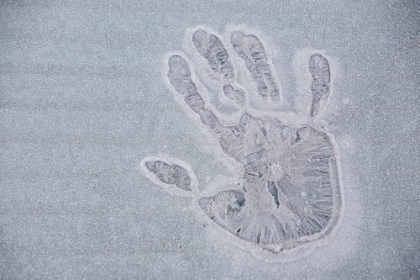
.

STSE Links
Can this method be used to create clean drinking water from salty ocean water?

Cross Curricular Connections
Art
- The students can draw their outline of the condensation on the window using erasable window markers. This activity also incorporates visual arts when producing a three-dimensional work of art that communicates a specific idea.

Math
- Geometry - Describe the three dimensional shapes of the containers used to collect water.
- Measurement - measure the volume of the water in the container and the volume of the water collected on the cling film.

.

